**CPU**

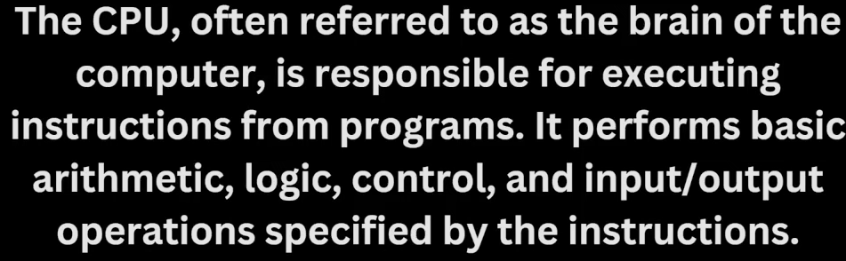

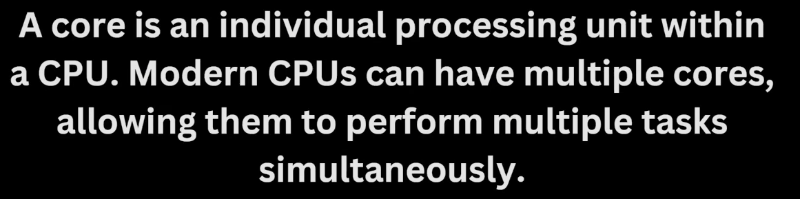

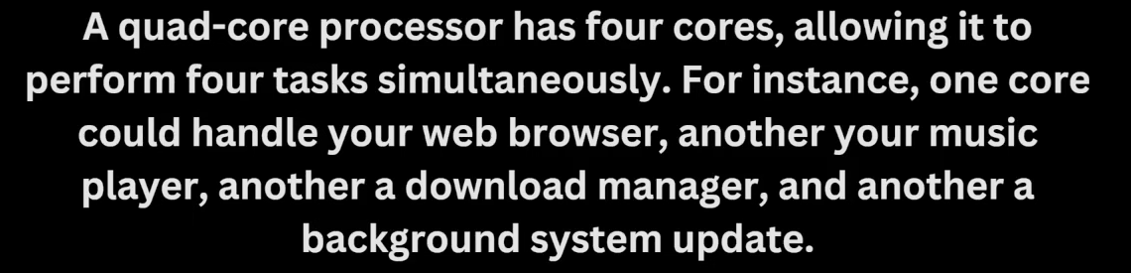

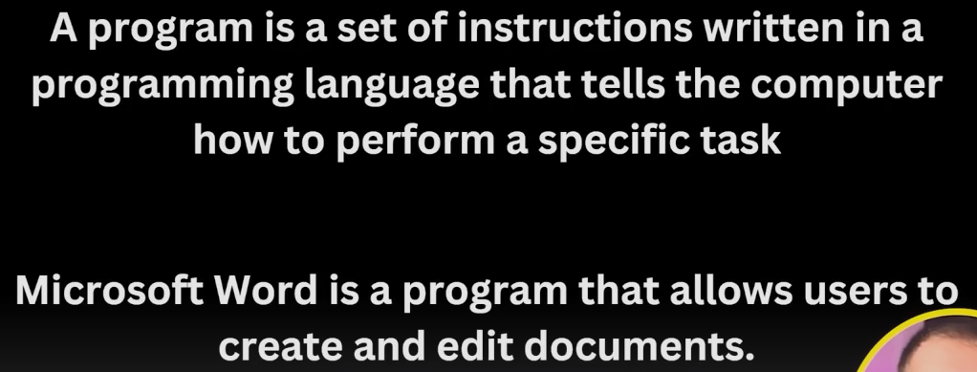

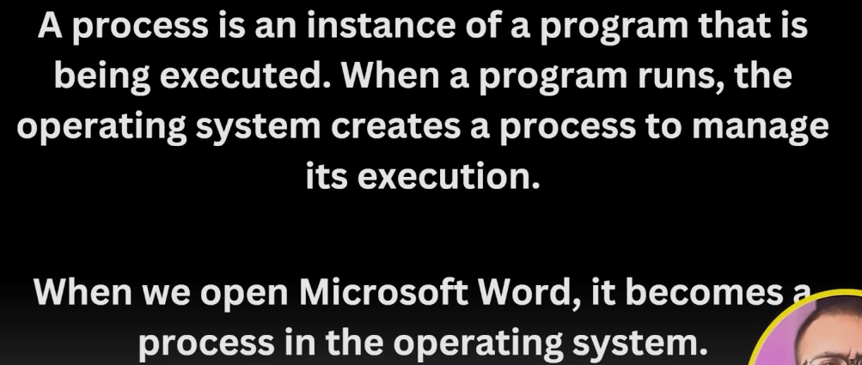

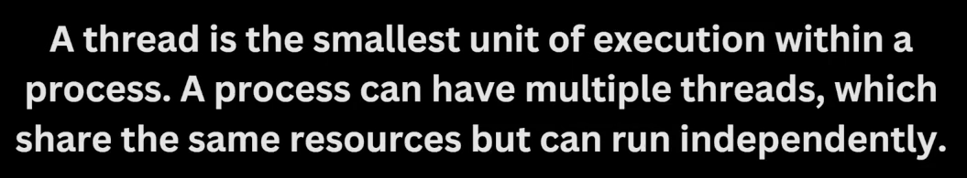

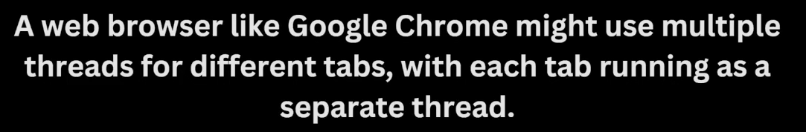

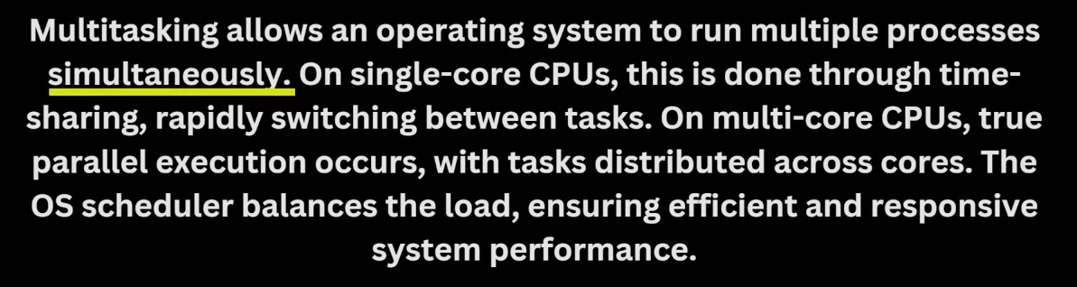



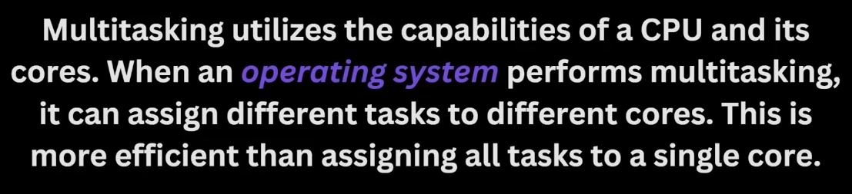

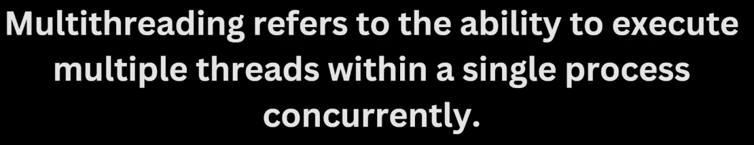

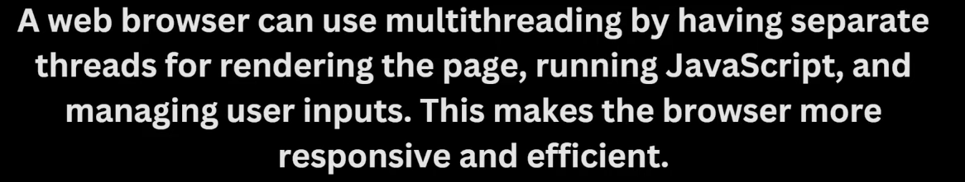

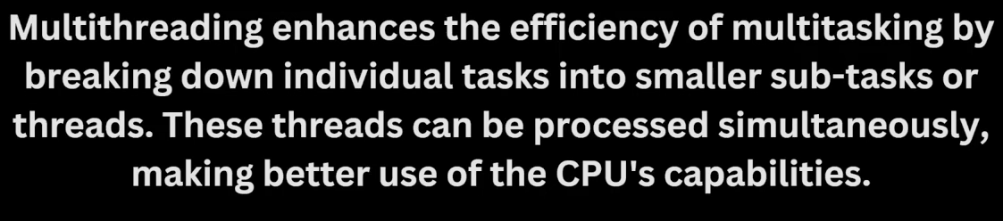

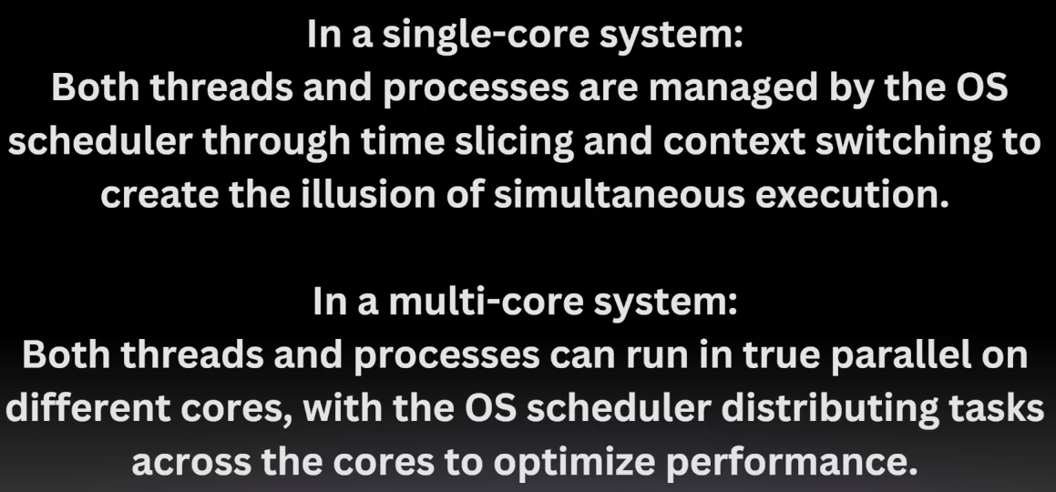

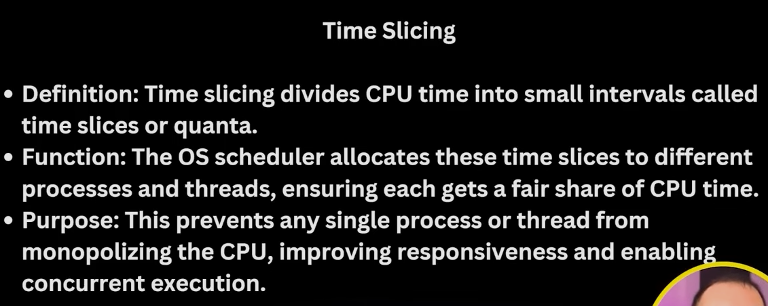

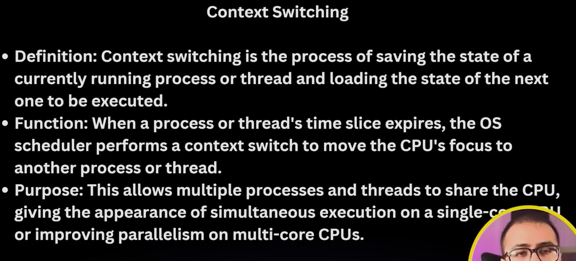

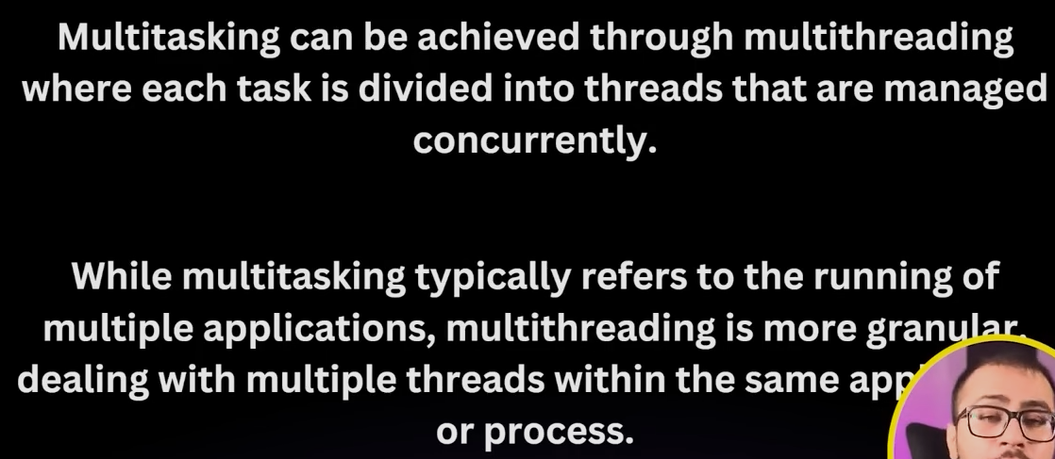

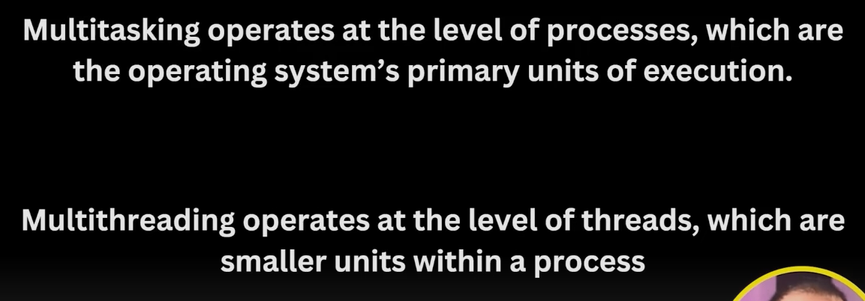

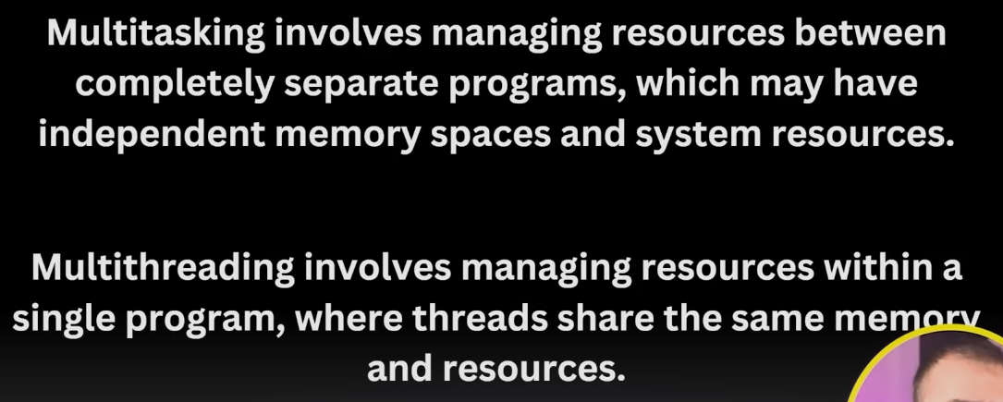

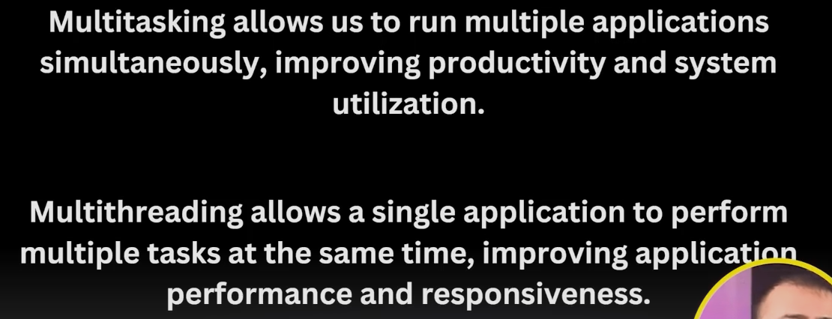

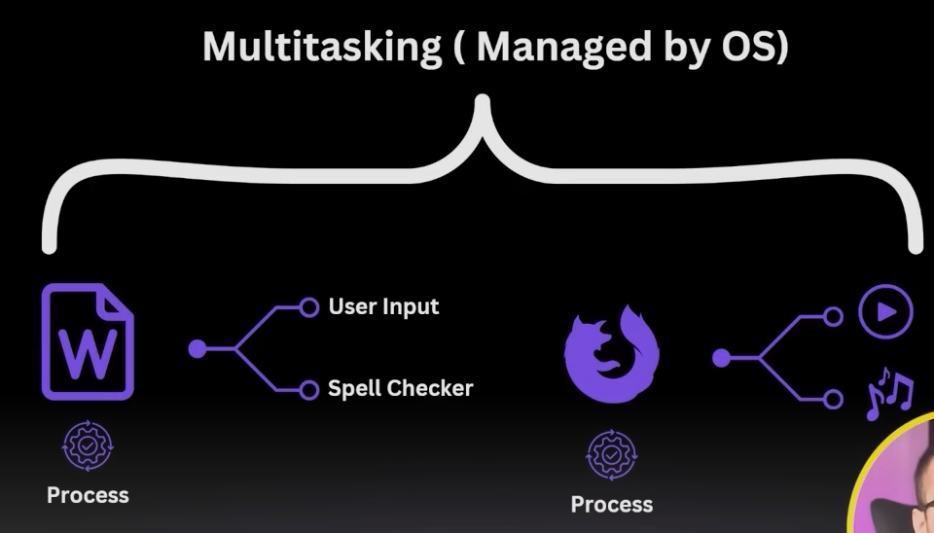

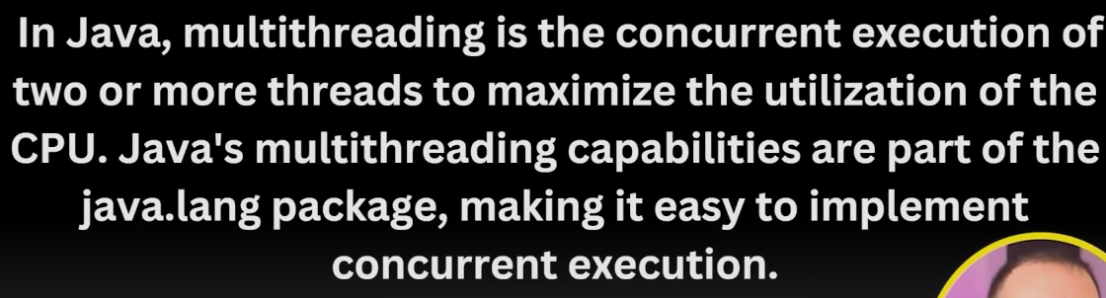

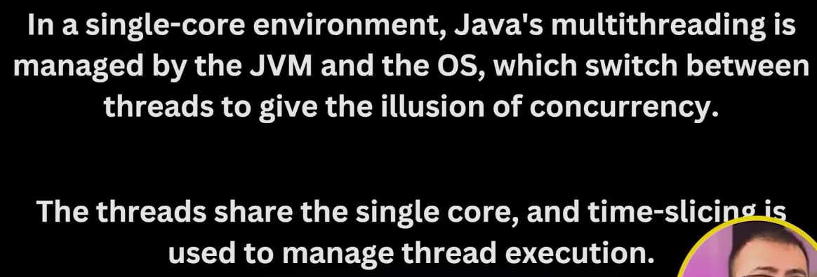

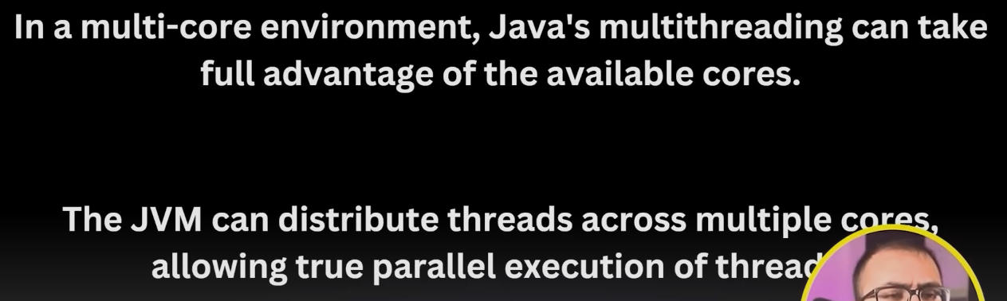

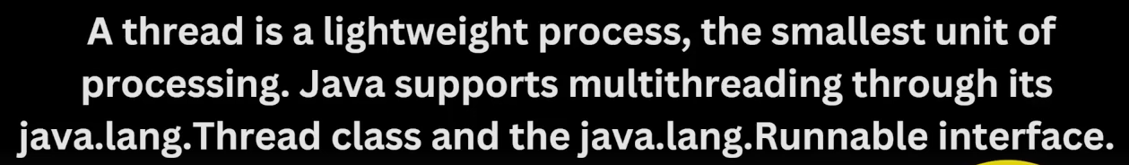

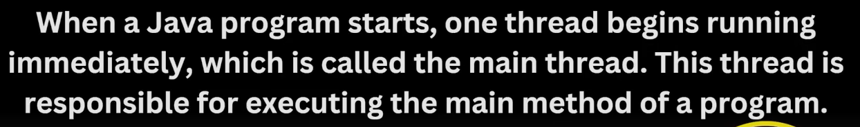

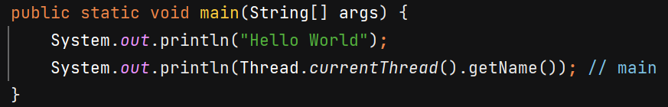

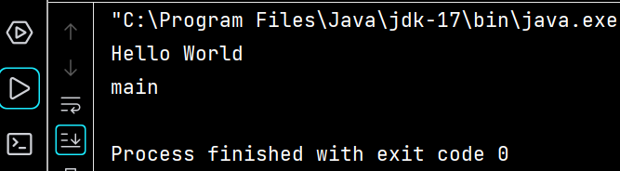



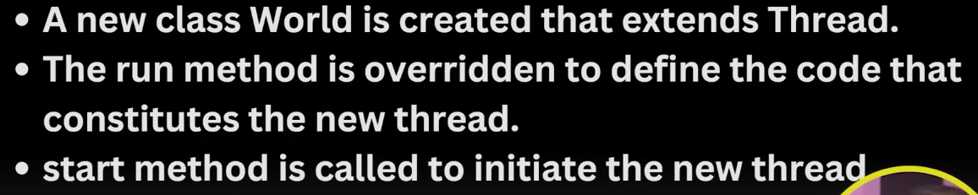

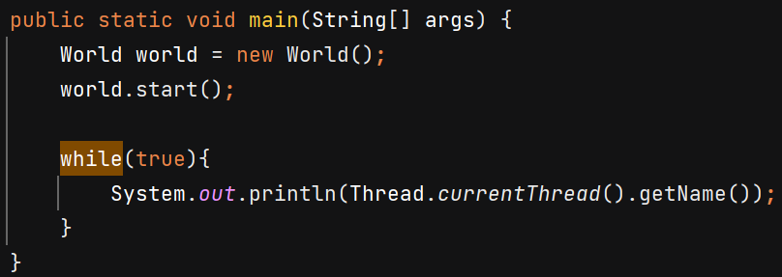

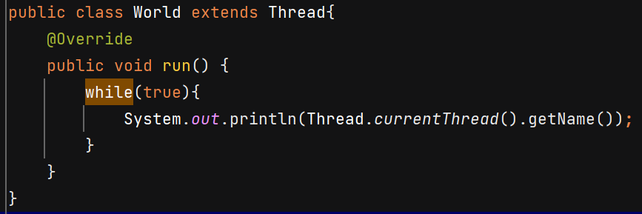

O/P - 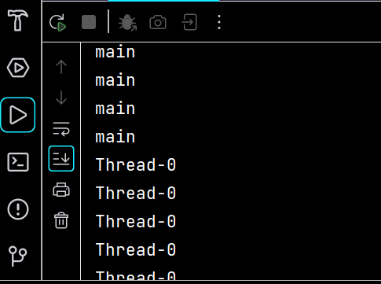

**Method 2** –

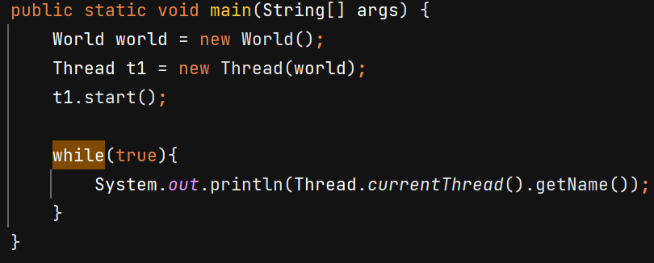

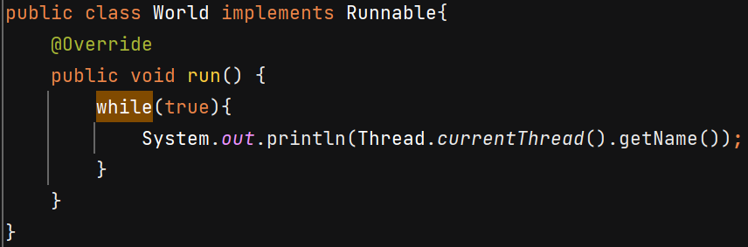

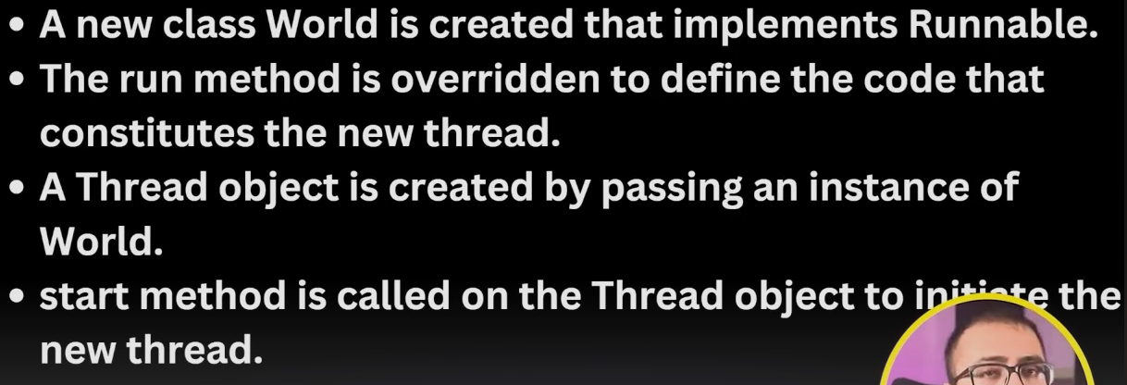



**Thread Lifecycle**

**New Thread:**When a new thread is created, it is in the new state. The thread has not yet started to run**.**

**Runnable State**: In this state, a thread might be ready to run at any instant of time or actually running.

**Blocked:** The thread will be in blocked state **when it is trying to acquire a lock** but currently the lock is acquired by the other thread.

**Waiting state**: The thread will be in waiting state when it calls wait() method or join() method. It will move to the runnable state when other thread will notify or that thread will be terminated.

**Timed Waiting**: A thread lies in a timed waiting state when it **calls a method with a time-out parameter**. A thread lies in this state until the timeout is completed. Ex- Thread.sleep()

**Terminated**: The thread has completed execution.

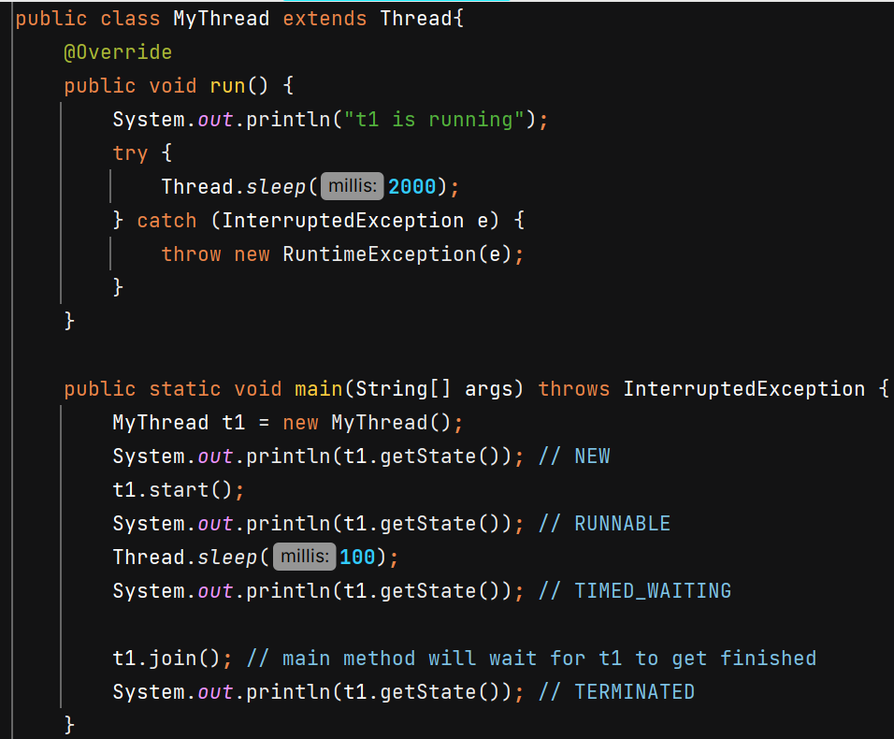

**Thread v/s Runnable**

Suppose class A already extends class B in that case we cannot extend it by Thread class also because multiple inheritance is now allowed, in this case class A should implement Runnable interface and override Run() method.

**Threads**

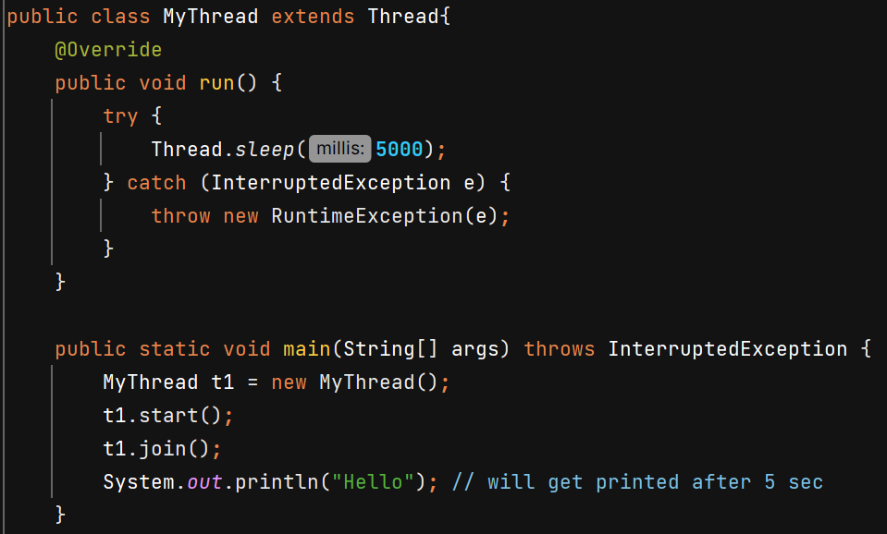

Join() will wait for thread to complete its execution

**Methods –**

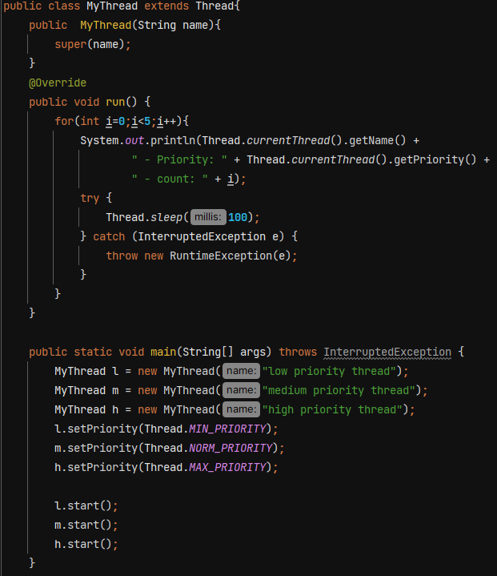

In constructor we can pass name of thread.

Using **setPriority()** we give hints to JVM about relative importance of threads, it is not strictly followed. Maybe thread with low priority execute earlier than thread with medium priority.

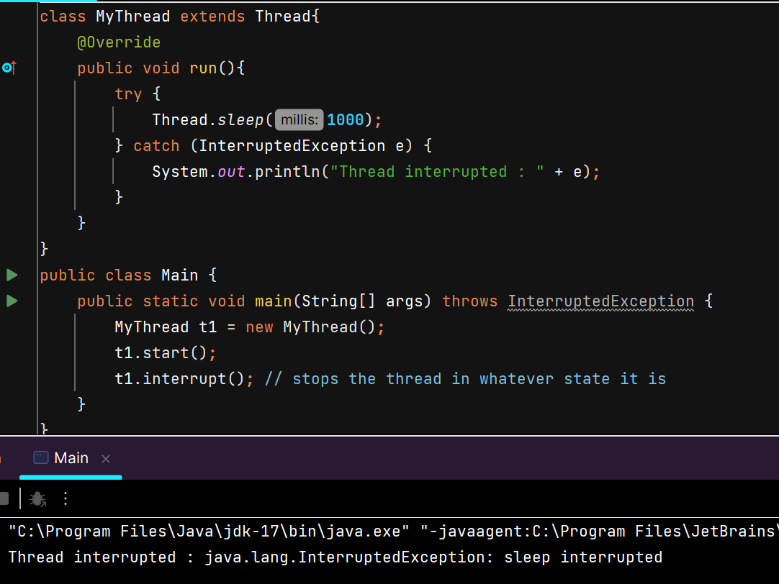

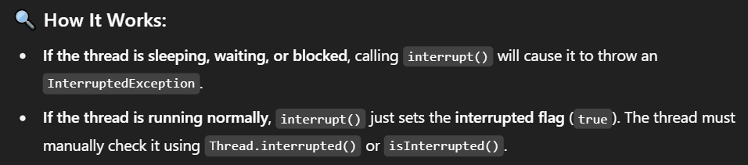

**Yield()** - Used to hint to the thread scheduler that the current thread is **willing to pause** its execution and **current use of processor**to let other threads run. The scheduler is free to ignore this hint.

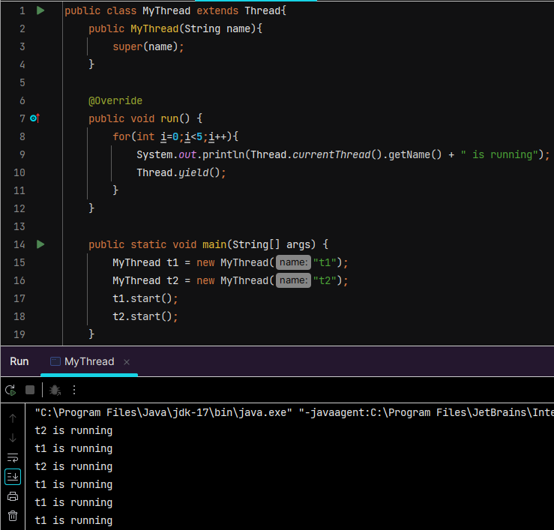

**User Thread** – Any **normal thread** that performs the **main work of the application**. Whatever work we are performing inside run() method are done with help of user threads.

The **JVM will continue running** as long as there is at least **one user thread** still active — it **waits for all user threads to finish** before shutting down.

**Daemon Thread** – they run in background. Ex- garbage collector in Java.

**JVM does not wait** for them to finish when the program is exiting. As soon as main thread, all other user threads are done, daemon threads are also terminated and JVM terminates.

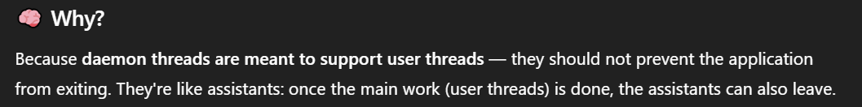

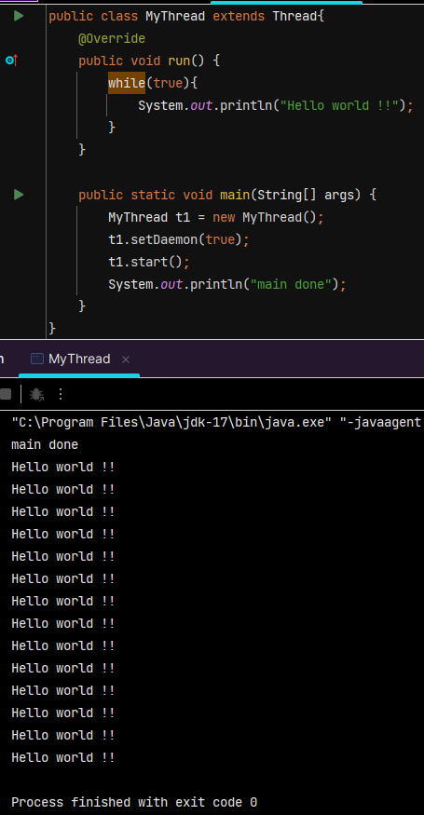

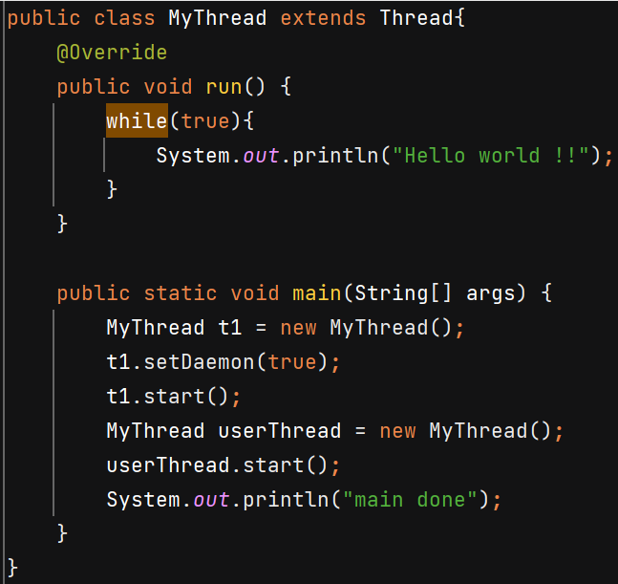In this case both threads keep running and JVM will wait for userThread to finish.

**Synchronization**

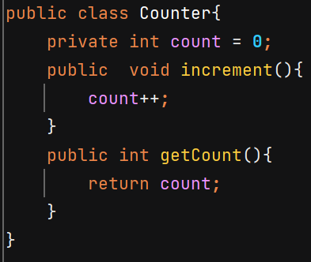 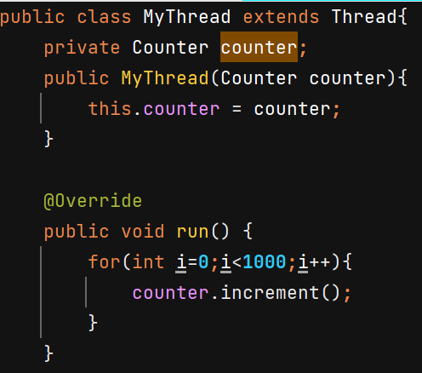

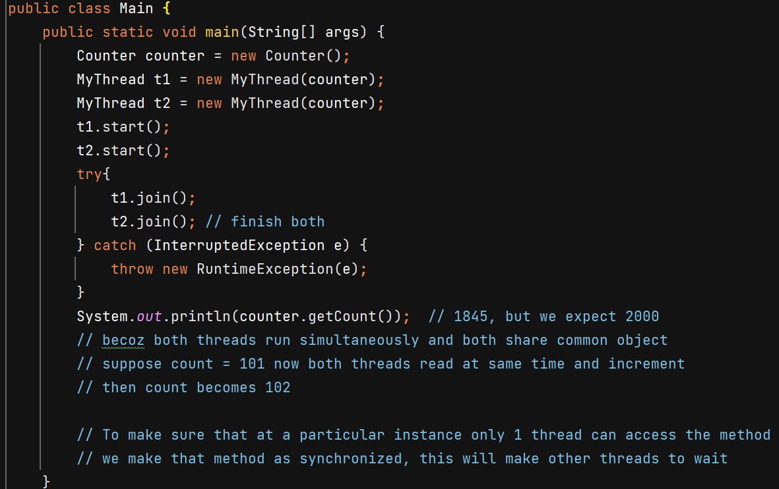

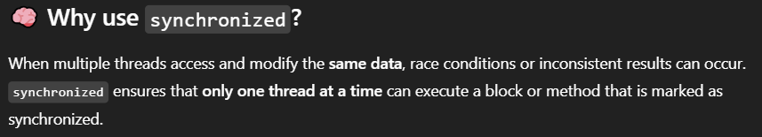

**Synchonized instance methods** 🡺 Only **one thread per object instance** can execute this method at a time.

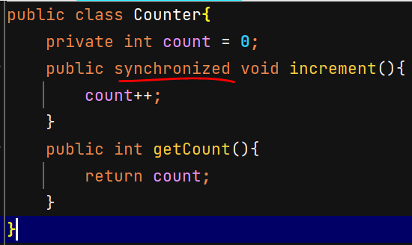 Now O/P – 2000

Instead of whole method we can make a particular **block synchronized** –

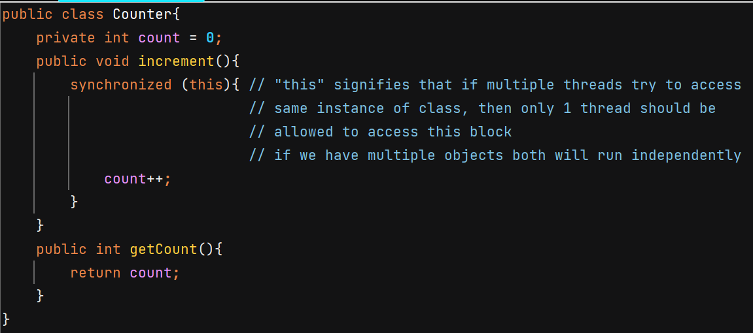

Both **synchronized(ClassName.class)** and a **static synchronized method** use the class-level lock.

**synchronized(object)** 🡺 acquires intrinsic lock of that object

**Critical section** – Part of our code where shared resources are accessed and modified. Ex- increment() method in above example.

**Race Condition** – when multiple threads are working on shared resources and if their timing conflicts it can lead to unexpected results.

**Mutual Exclusion** – condition when only 1 thread can access the critical section

**Locks** – after using synchronized keyword on method we achieve mutual exclusion it is done by locking. When 1 thread is working on shared resource it puts lock on it and when it is done, it releases the lock.

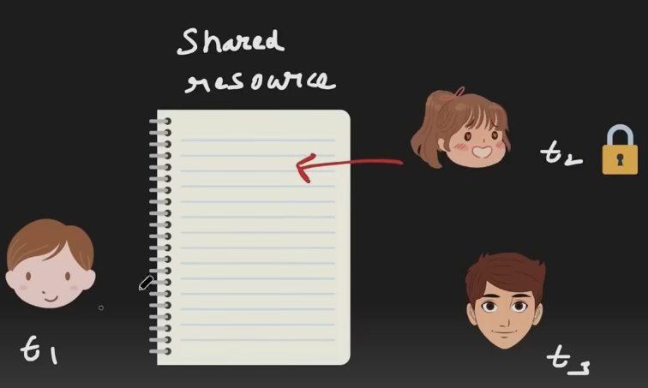

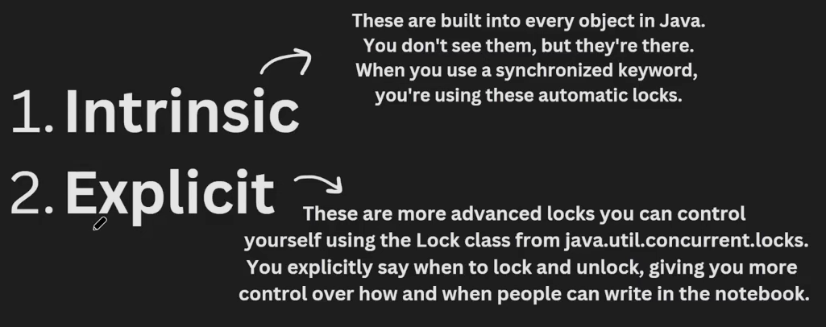

An **intrinsic lock** (or monitor lock) is a **built-in synchronization mechanism** that every Java object has.

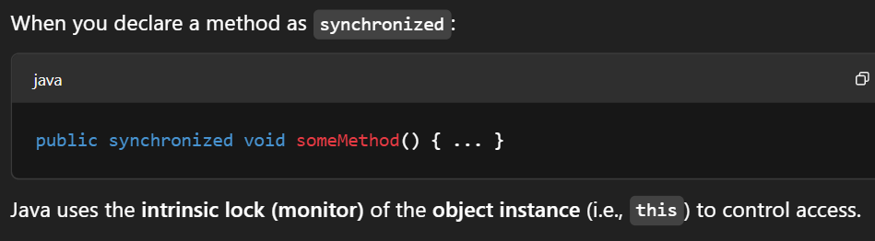

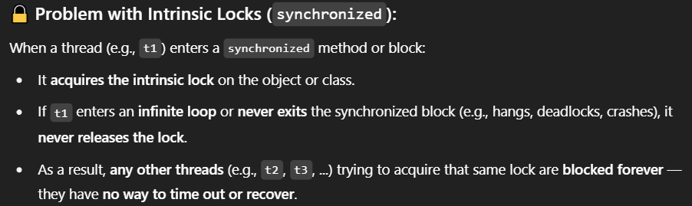

You can’t interrupt a thread that’s waiting on a synchronized block/method.

Explicit locking can solve it.

**Lock** is interface and **ReentrantLock** is its impl class.

Lock.lock() 🡪 Acquires the lock **if available**, otherwise thread will wait for acquiring lock in BLOCKED state, just like synchronized.

.tryLock() 🡪 Acquires the lock if it is available and returns immediately with the value true. If the lock is not available then this method will return immediately with the value false. Prevents deadlocks by not waiting forever.

.tryLock(**1000,** TimeUnit.*MILLISECONDS*) 🡪 Acquires the lock if it is free within the given waiting time and the current thread has not been interrupted. If the lock is available this method returns immediately with the value true.

.unlock 🡪 Releases the lock. Should **always be in a finally block** to ensure it’s released.

**Note :-** The reason why Sonar suggests to re-interrupt the thread is because by the time the exception occurs, the thread's interrupted state may have been cleared, so if the exception is not handled properly the fact that the thread was interrupted will be lost.

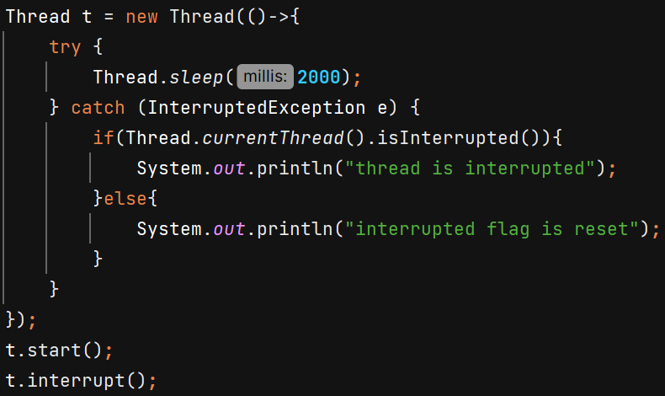 O/P – interrupted flag is reset

Example :-

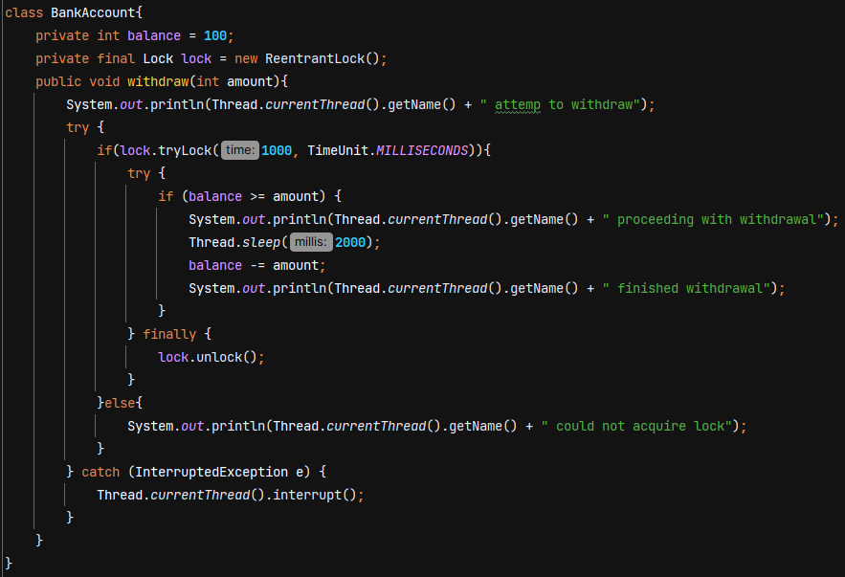

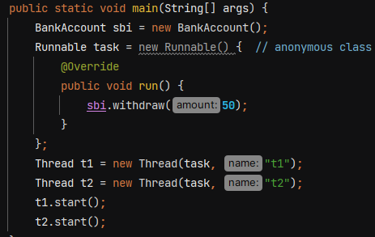

O/P - 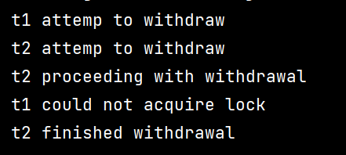

**Deadlock**

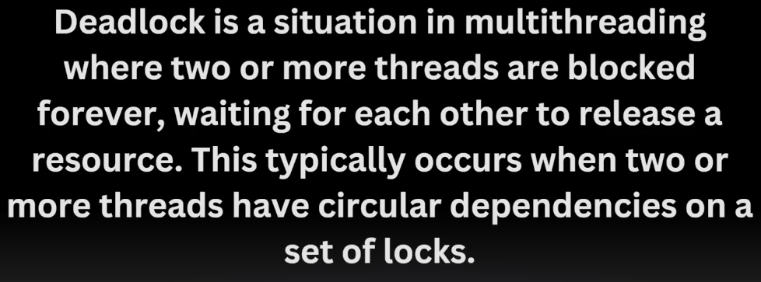

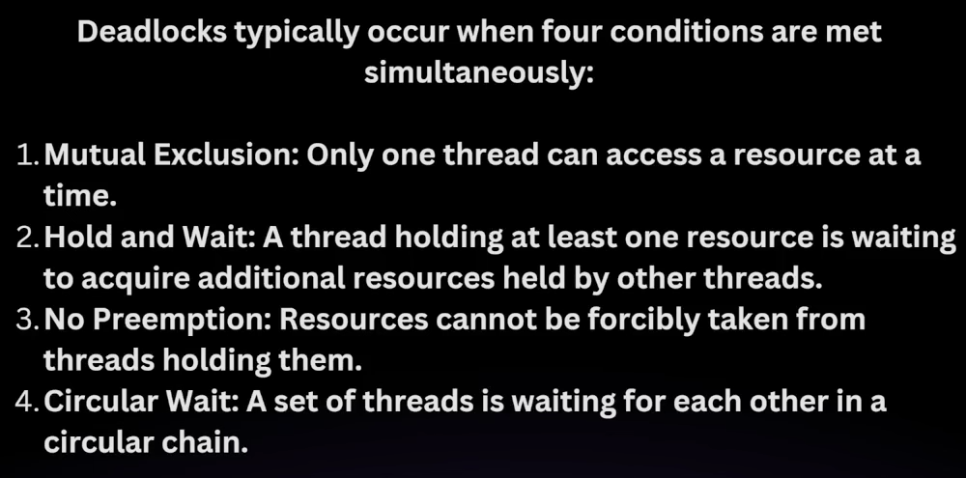

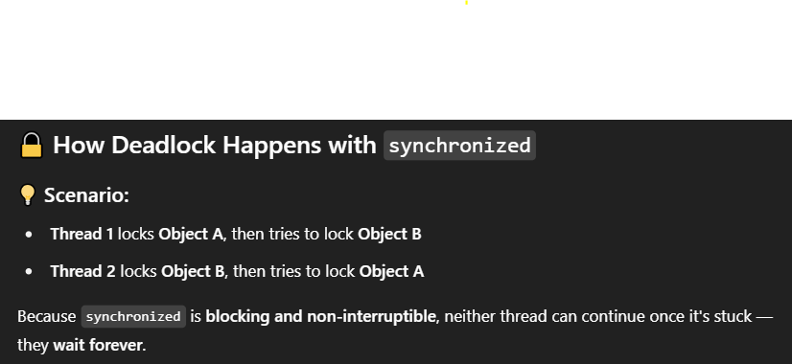

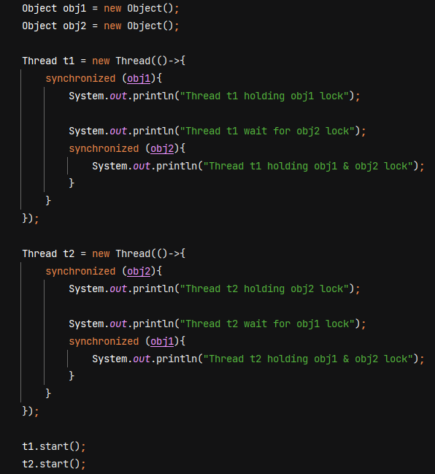

Example :-

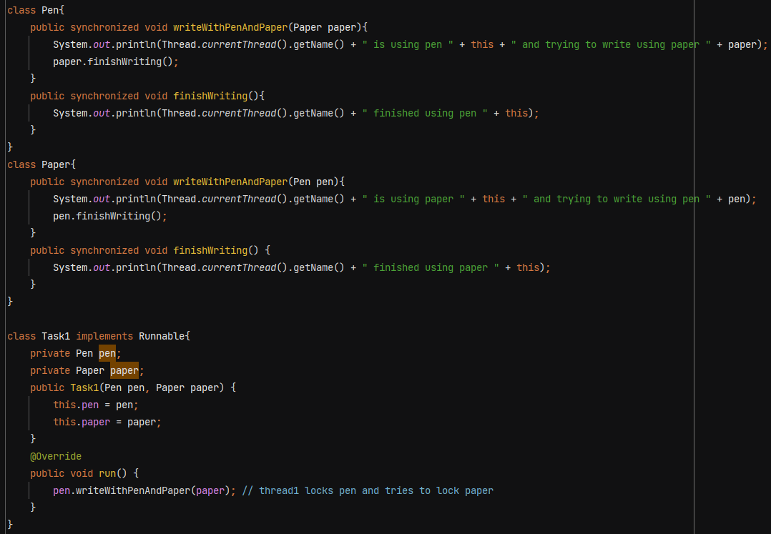

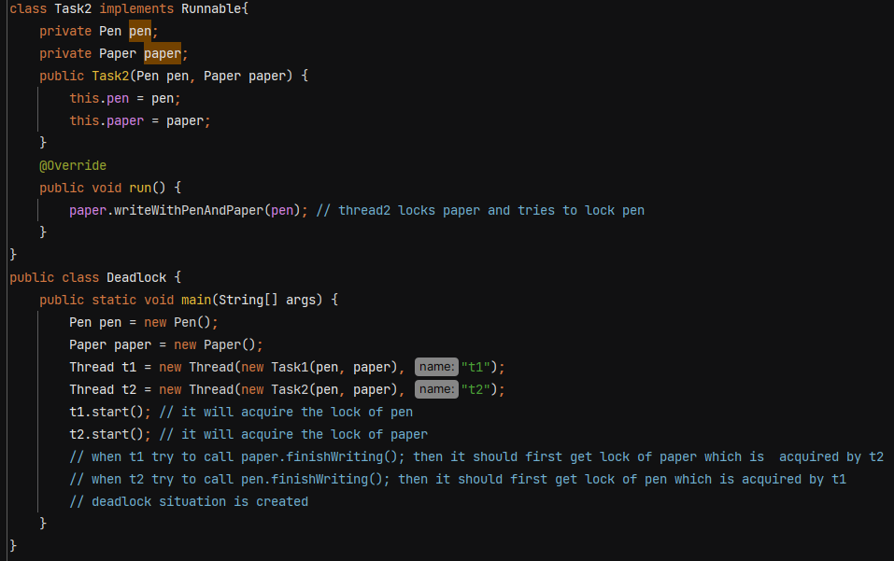

To avoid deadlock ensure that all the threads acquire locks in consistent order.

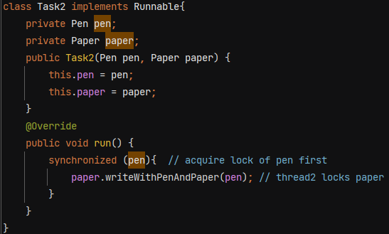This will ensure that t2 will run only when it locks both pen and paper

**Deadlock Prevention in ReentrantLock**

If a thread already holds a lock, it can acquire the same lock again, without blocking.

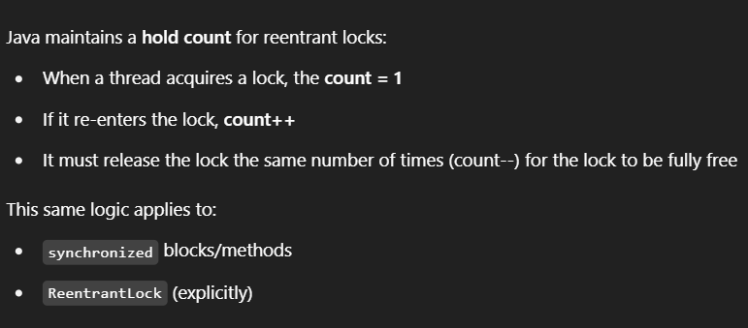

Java's intrinsic locks (used with synchronized) are also reentrant.

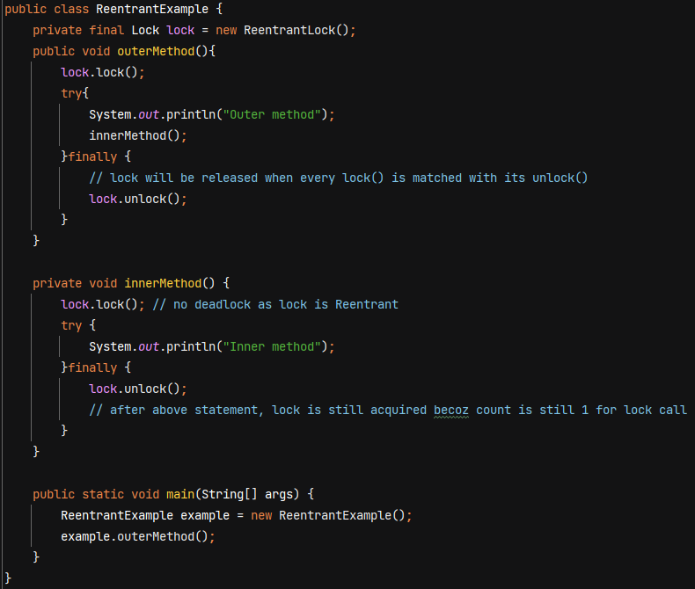

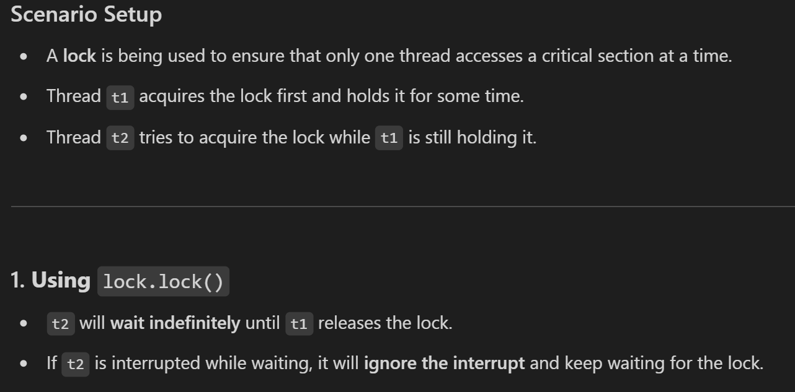

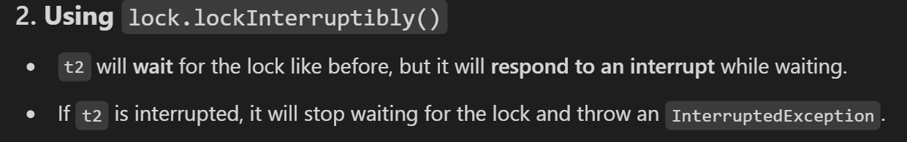

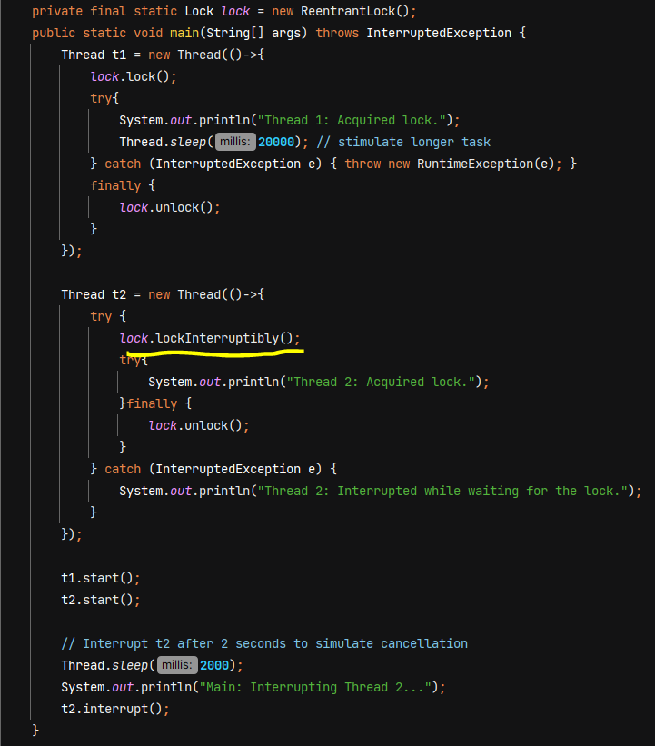

O/P - 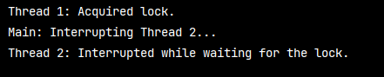

**Lock’s Fairness**

* A fair lock ensures that threads acquire the lock in the order they requested it  
  (i.e., a first-come, first-served basis)
* A thread will not starve (i.e., will not have to wait indefinitely) because threads that arrived earlier in the queue are guaranteed to get the lock before any new threads.
* A non-fair lock (when fairness is set to false) does not guarantee order

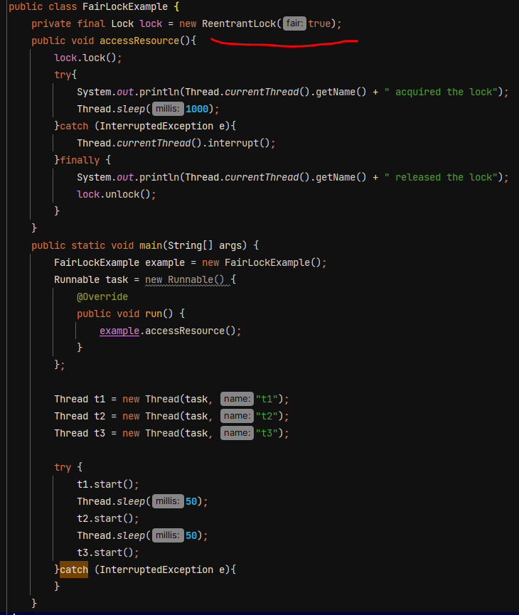

Problems with Synchronized –

* No fairness
* indefinitely blocking to acquire lock
* No Interruptibility
* No distinguish between read /write operations – synchronized will block every thread.

**ReadWriteLock** – it allows multiple threads to read resources concurrently as long as no thread is writing to it. It ensures exclusive access for write operations.

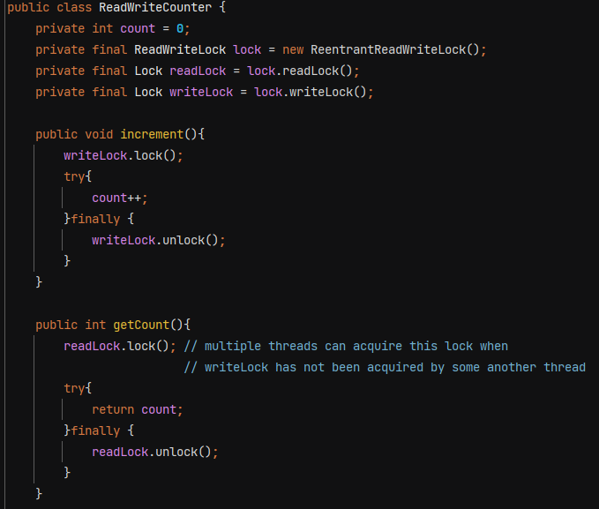

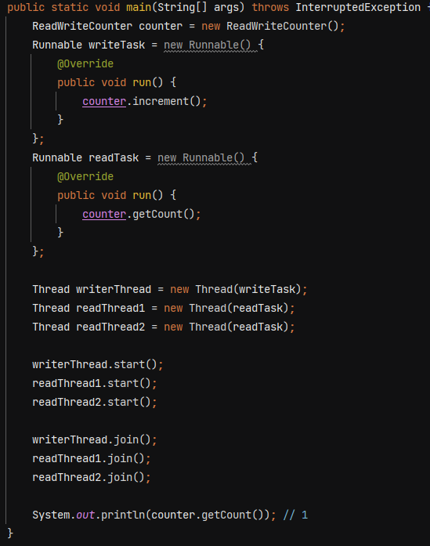

**Thread Communication**

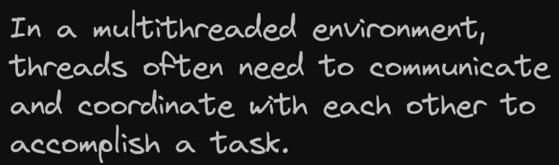

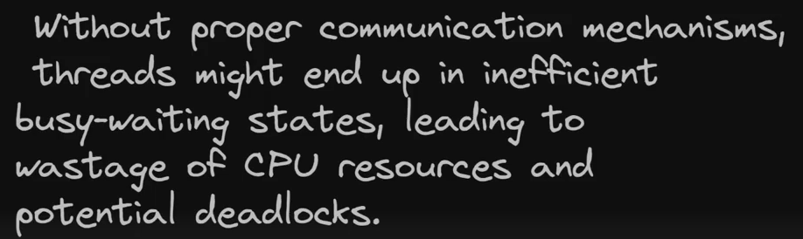

For thread communication, we have methods like wait(), notify() and notifyAll(). These methods belong to the **Object class**, not Thread.

Wait() 🡪 tells current thread to release the lock and wait until some other thread run notify() or notifyAll()

Notify() 🡪 wakes up a single thread that is waiting

NofityAll() 🡪 wakes up all threads that are waiting

These methods can only be called within a synchronized context. When you use methods like wait(), notify(), or notifyAll() on an object, the **calling thread must own that object's intrinsic lock**.

Ex- 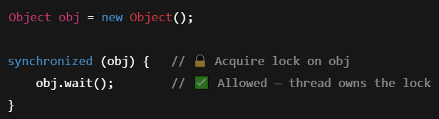

Ex-

We want Producer to produce data but wait if hasData is true. And Consumer should consume data when hasData is true.

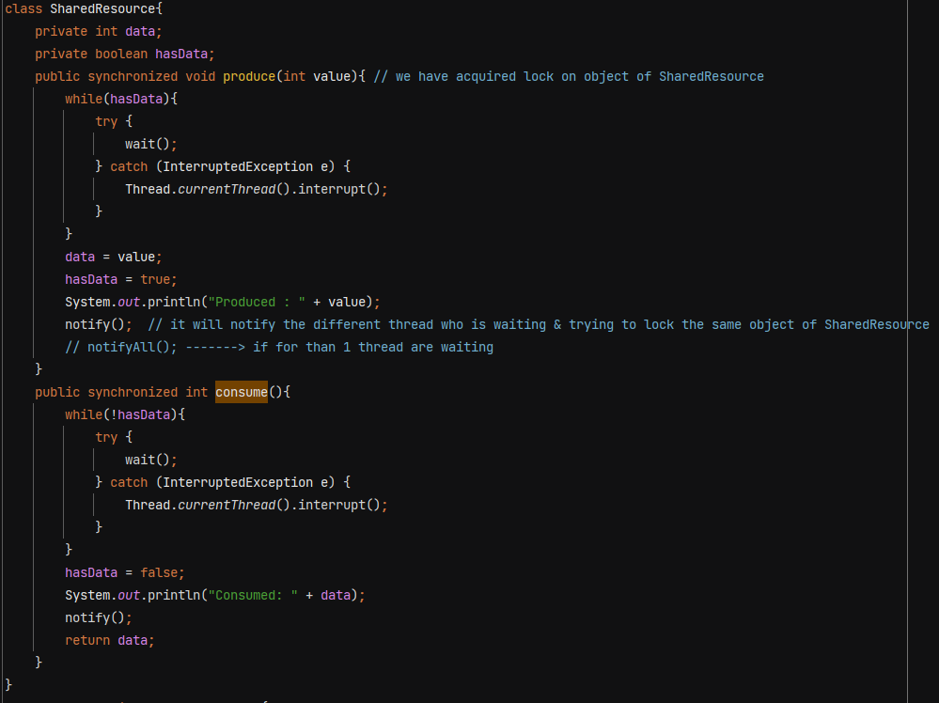

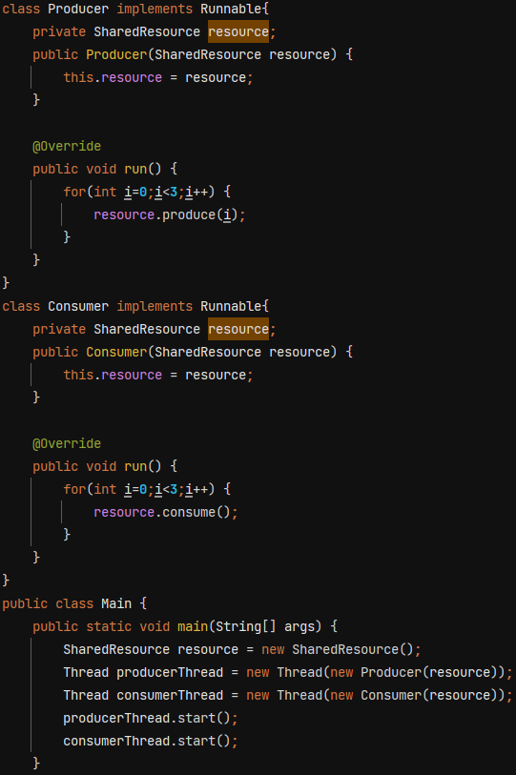

O/P - 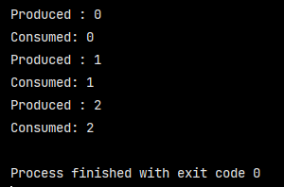

**Thread Safety** – a code is thread safe if it guarantee no unexpected results, no race condition when multiple threads try to access that piece of code with same object.

**Lambda Expression** – anonymous function

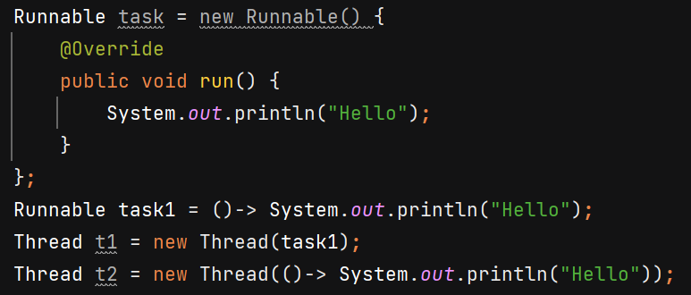

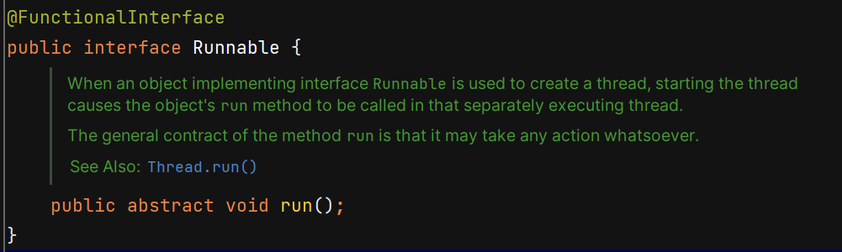 It does not return.

**Thread Pool** – collection of pre-initialised threads that are ready to perform a task.

Why ?

1. Resource management – every time creating and destroying threads is expensive.
2. Response time improves
3. Control over thread count – puts a limit on no of threads that can be created.

**Executors Framework**

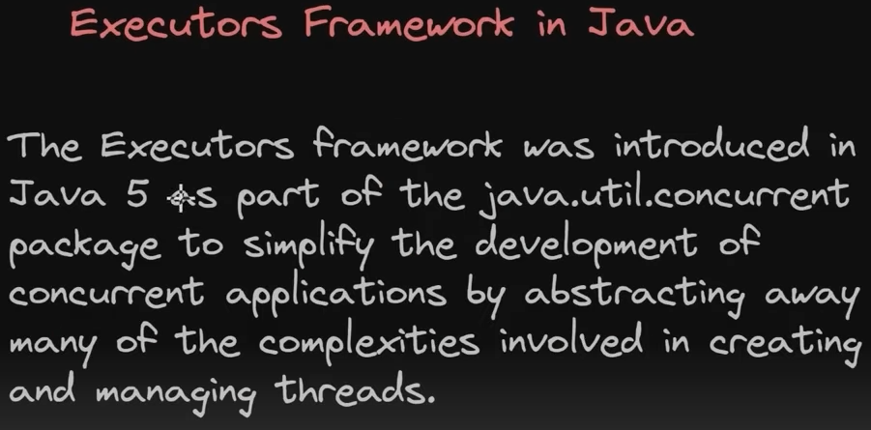

Problems prior to executors framework - 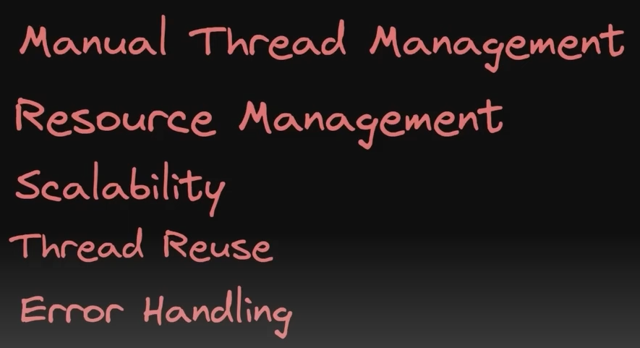

3 interfaces available – 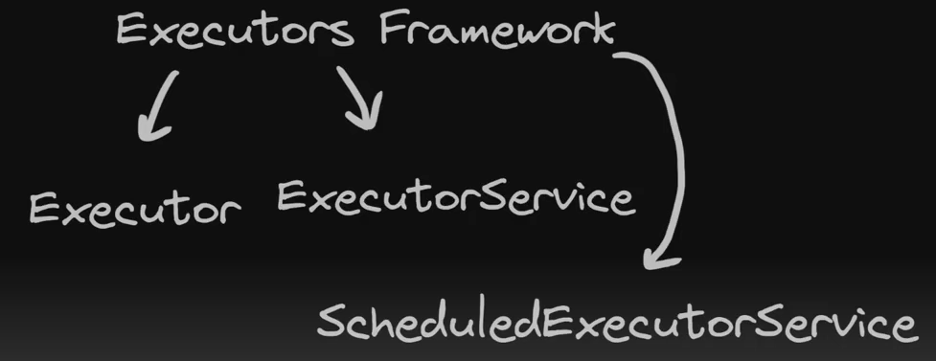

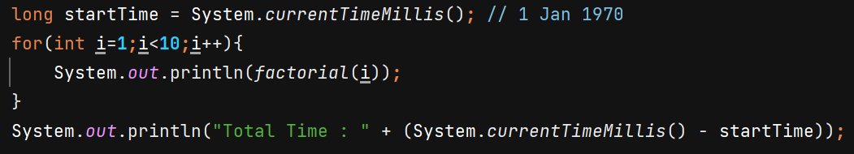

O/P- Total Time : 4575 ms

Using multithreading 🡺 O/P – 515 ms

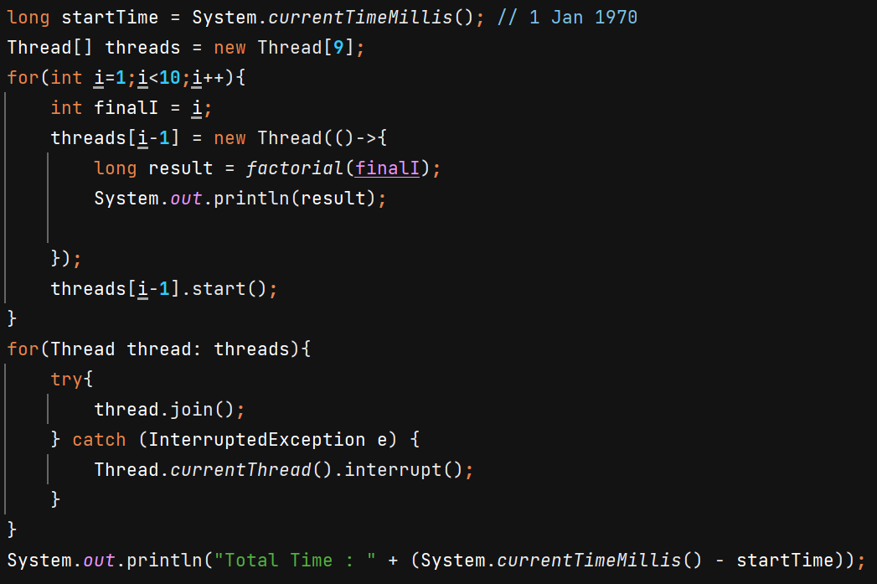

Using Executors Framework 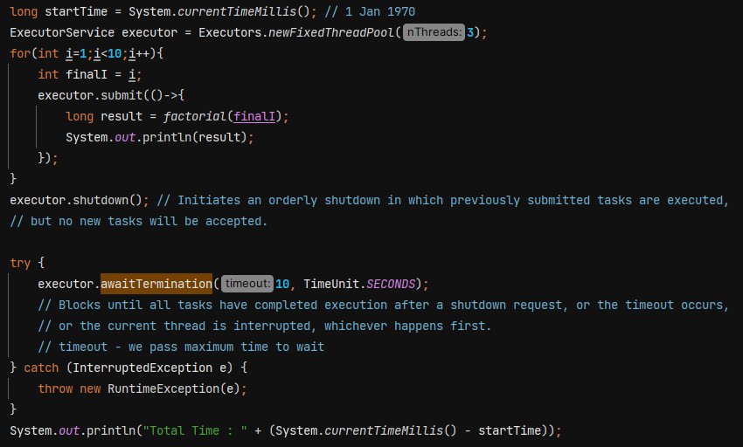

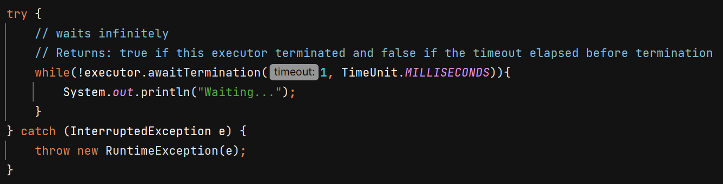

**submit()** 🡺 it accepts any number of tasks. The task is queued and will execute automatically if a thread from the pool is available.

**shutdown()** 🡺 Gracefully shut down the executor service. It does not block the current thread.

**shutdownNow()** 🡺 Forcefully stops all running/waiting tasks.

**awaitTermination()** 🡺 Returns true if this executor terminated and false if the timeout elapsed before termination



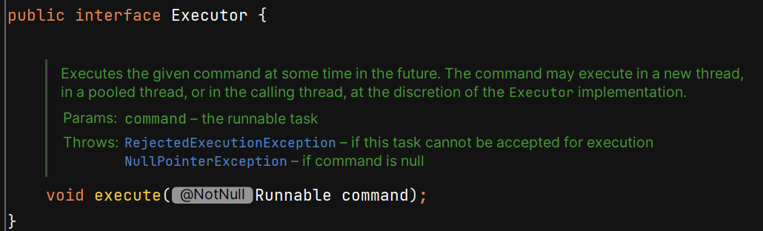

Executor does not contain methods like shutdown() so u need to manually do it. That’s why its useless. We’ll use ExecutorService becoz it provides more features.

**Submit()** method returns **Future<T>** which represents the result of an asynchronous computation.

future**.get()** blocks the current thread until task completed, or thread interrupt or execption thrown.

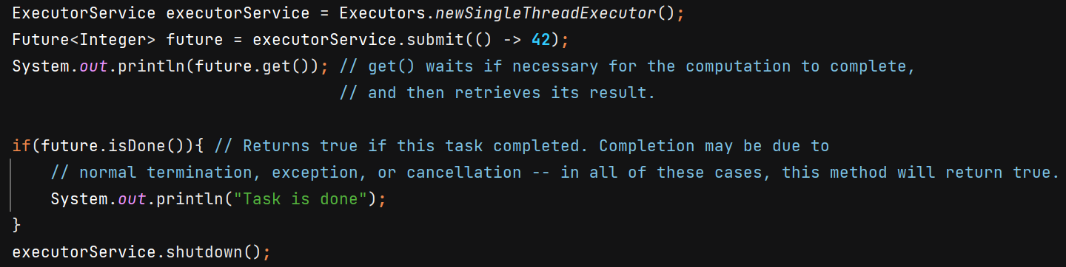

O/P - 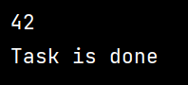

Submit() can take Runnable as well as Callable – 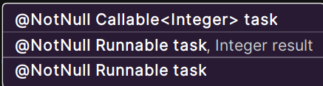

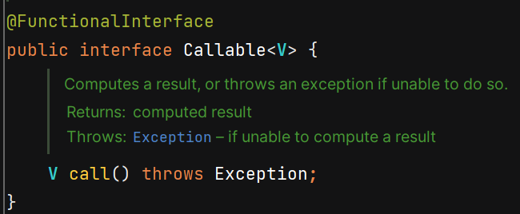 Callable returns value.

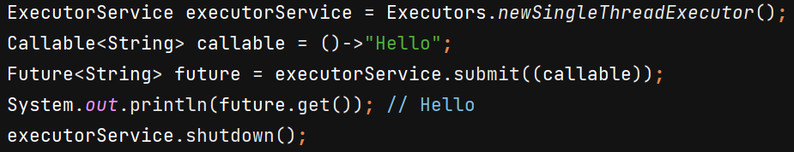

submit() method of Runnable argument is called -

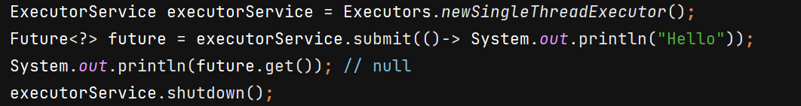

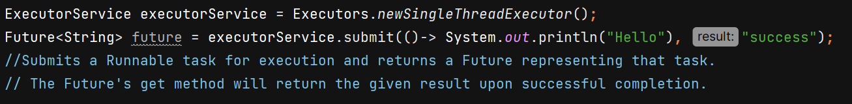

Difference - 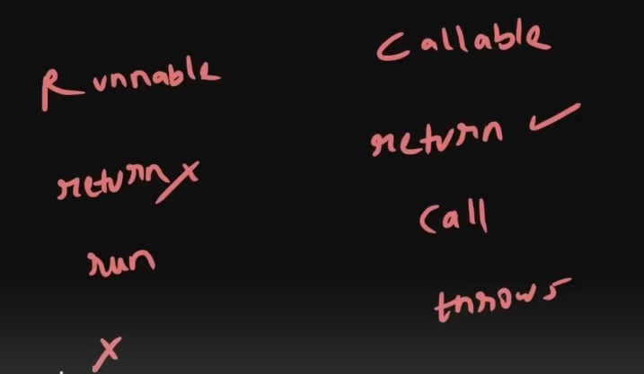

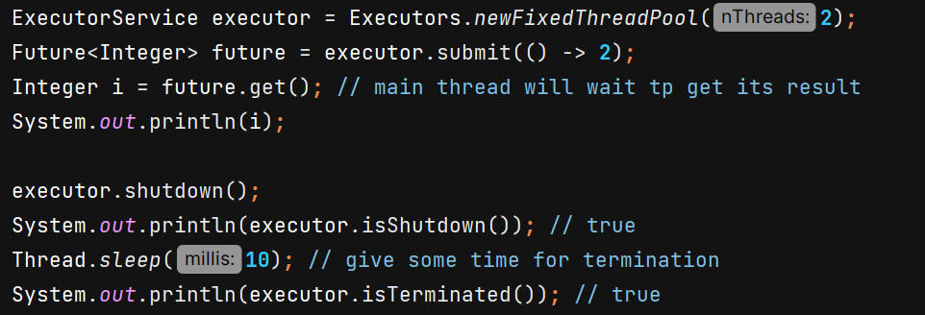

**isTerminated()** 🡺 return true if all tasks have completed after shut down

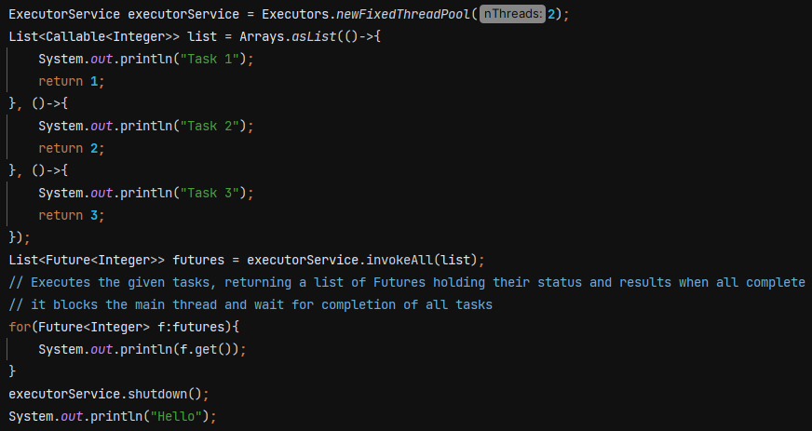

O/P 🡪 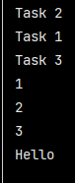

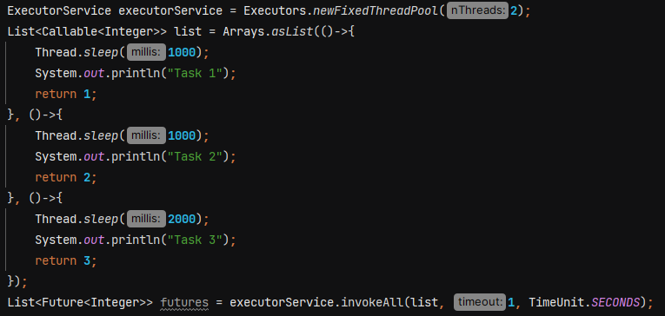

O/P 🡪 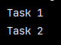

When we pass timeout in constructor, then it executes all the task which can be executed within time frame and other tasks are cancelled.

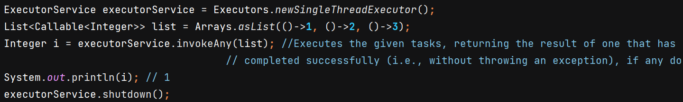

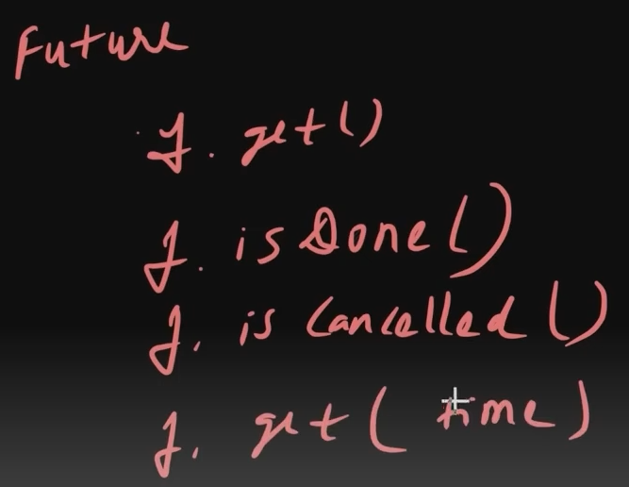

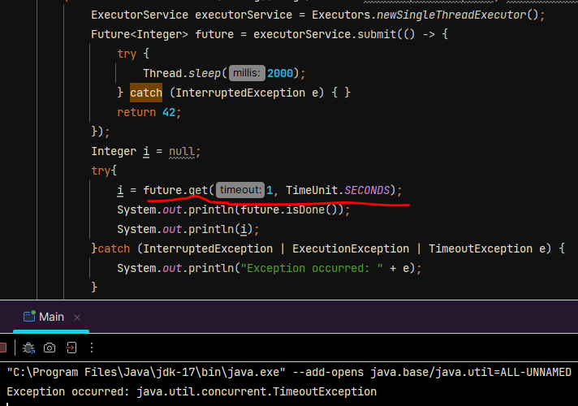

Explaination :- It waits for 1 sec, if task get completed then fine otherwise it gives TimeoutException.

**isDone()** 🡺 Returns true if this task completed. Completion may be due to normal termination, an exception, or cancellation.

**cancel()** 🡺 If the task has not started when cancel is called, this task will never run. If the task has already started, then the mayInterruptIfRunning parameter determines whether the thread executing this task interrupted in an attempt to stop the task.

* If the task has already completed it cannot be cancelled and .**cancel()** returns false.
* If task is still running it can be cancelled and **.cancel()** returns true. Futrue will not return any value and we get **CancellationException** if we use **.get()**

**isCancelled()** 🡺 Returns true if this task was cancelled before it completed normally.

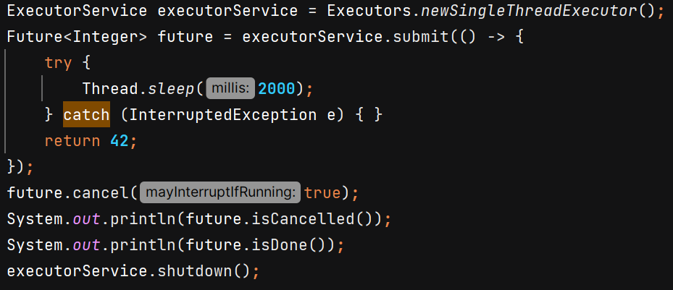

O/P 🡪 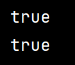

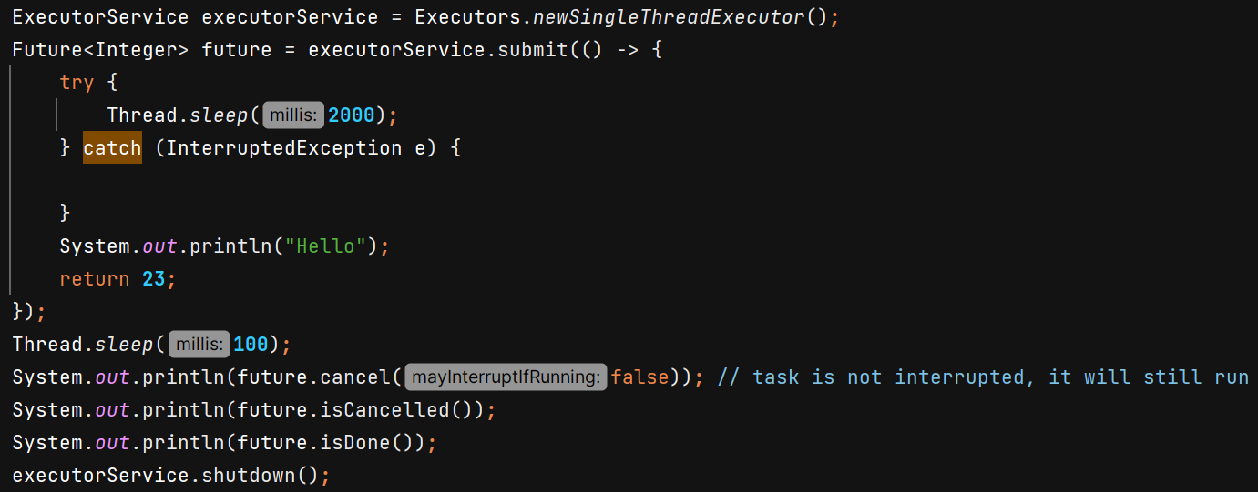

O/P 🡪 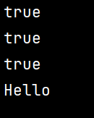

**Scheduled Executor Service** – used when we want something to run periodically.



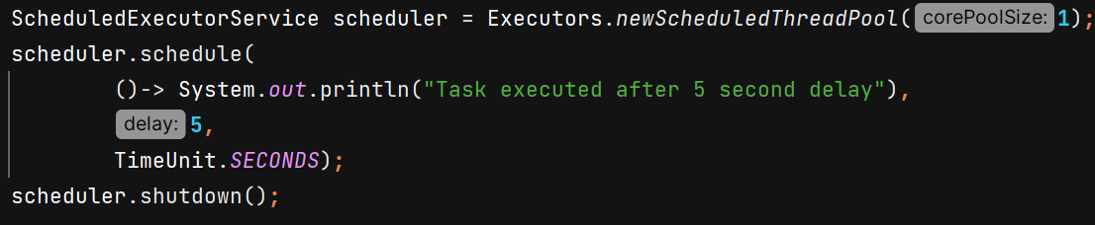

O/P 🡪 

On running .**schedule()** task will immediately go inside queue for execution and scheduler will wait for it to finish then shutdown.

But on running .**scheduleAtFixedRate()** it will not immediately come into queue. If scheduler.shutdown() is called **before the initial delay expires**, the scheduler will terminate immediately, and the task will never run. So we need to handle it properly –

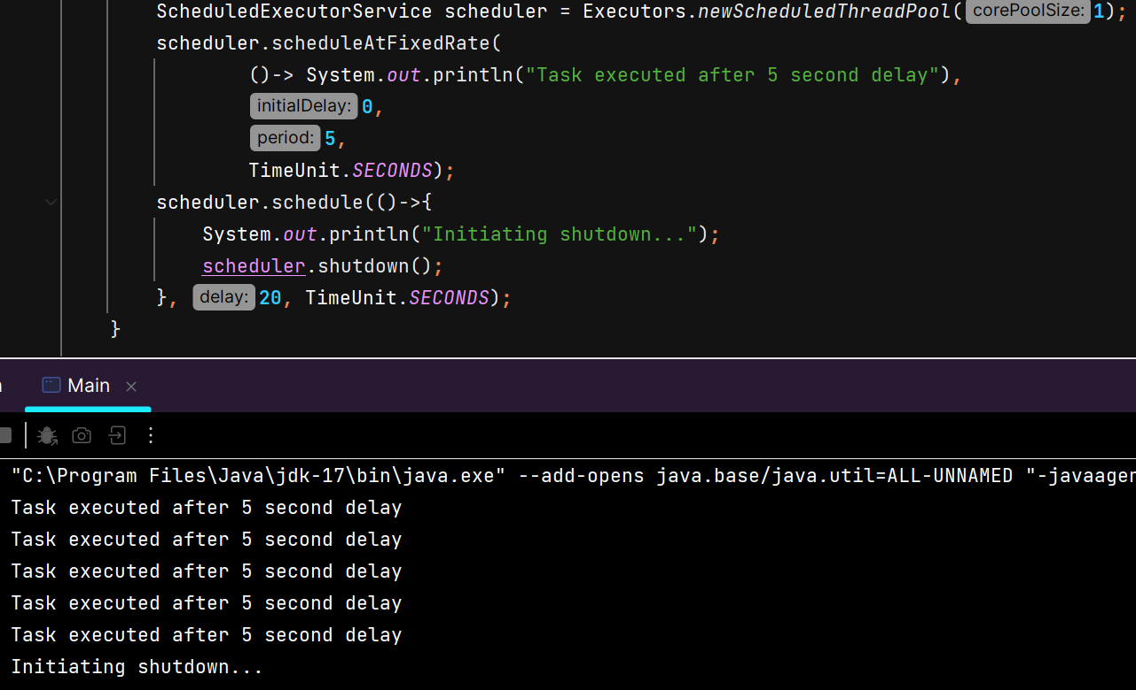

**scheduleAtFixedRate()** 🡺 Submits a periodic action that becomes enabled first after the given initial delay, and subsequently with the given period; that is, executions will commence after initialDelay, then initialDelay + period, then initialDelay + 2 * period, and so on.

**scheduleWithFixedDelay()** 🡺 Submits a periodic action that becomes enabled first after the given initial delay, and subsequently with the given delay between the termination of one execution and the commencement of the next.

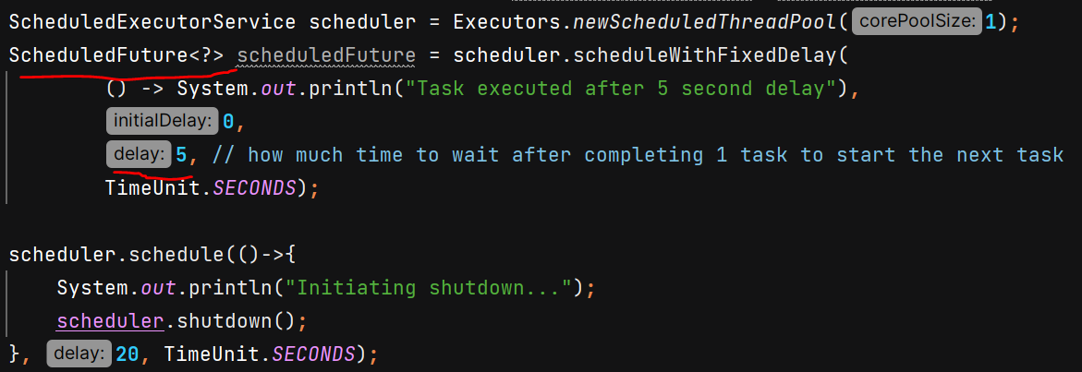

O/P 🡪 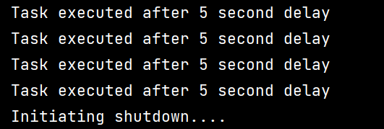

**Cached Thread Pool –** It creates a thread pool where it creates new threads as per need and terminates then after 60 seconds of inactivity. It dynamically adjusts the pool size. It is useful when load is variable and short lived. Do not use it when task are very time consuming.



**CountDownLatch** – It allows one or more threads to wait for a set of operations being performed by other threads to complete before proceeding further.

**count –** the number of times countDown must be invoked before threads can pass through await

Ex- we want to achieve that our main thread wait for some other dependent services.

Without – 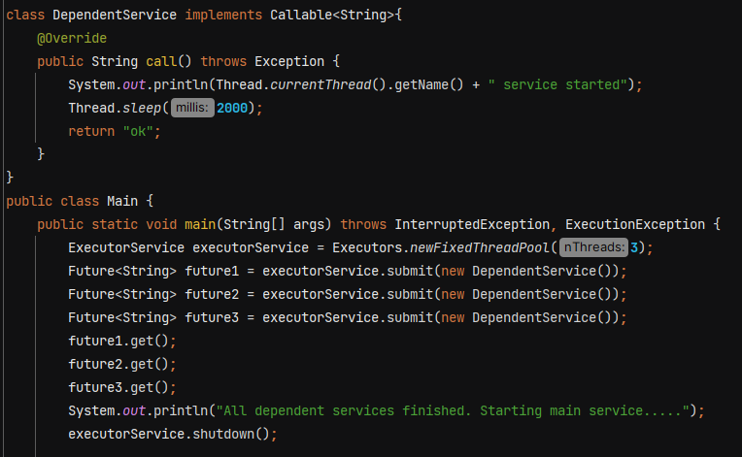

**With CountDownLatch -** 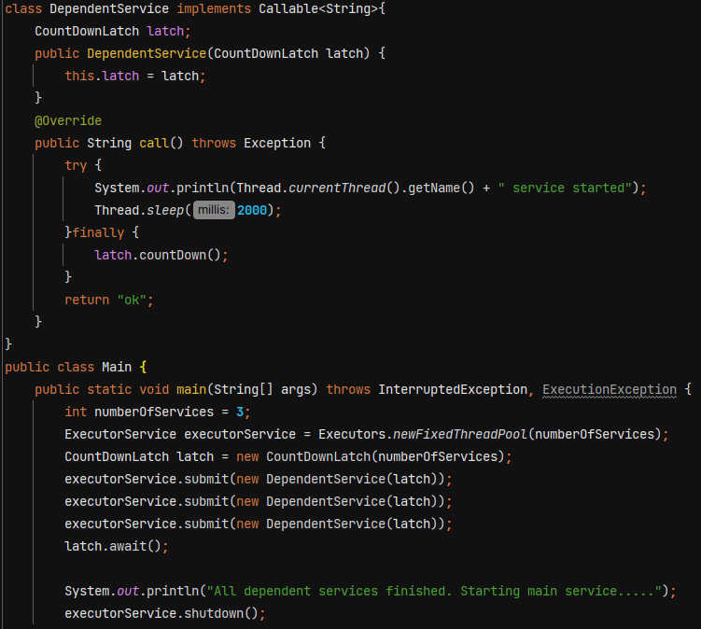

O/P 🡪 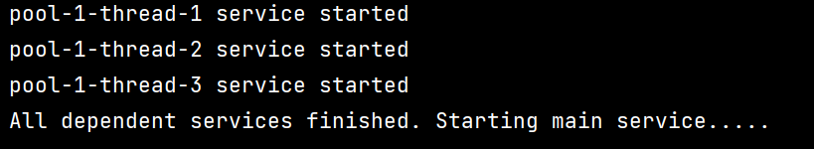

**Using threads –**

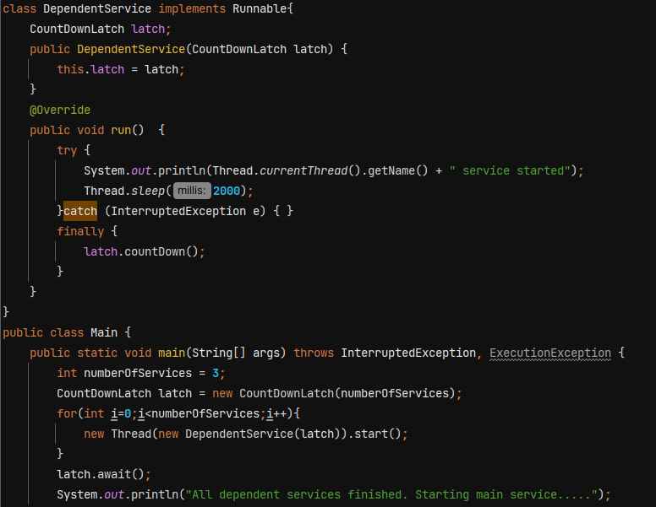

O/P 🡪 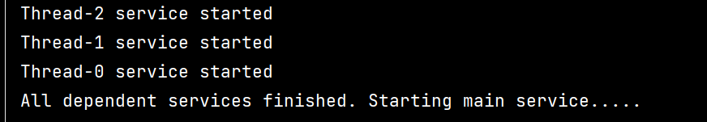

**await()** 🡺 Causes the current thread to wait until the latch has counted down to zero, unless the thread is interrupted.

We can also pass timeout in await()

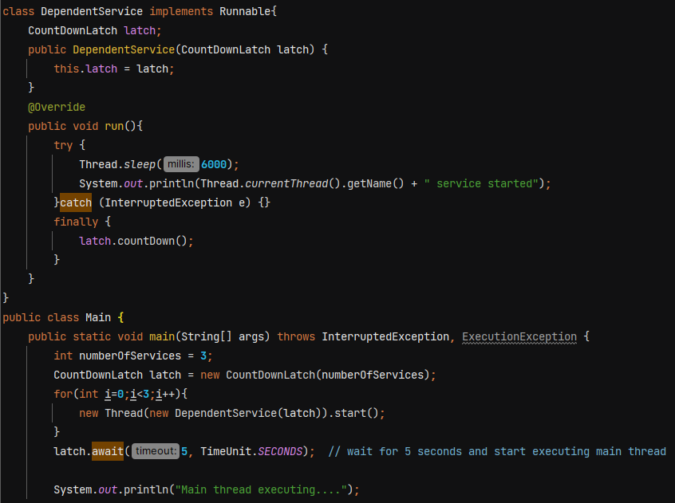

O/P 🡪 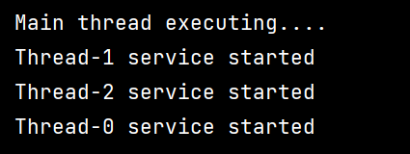

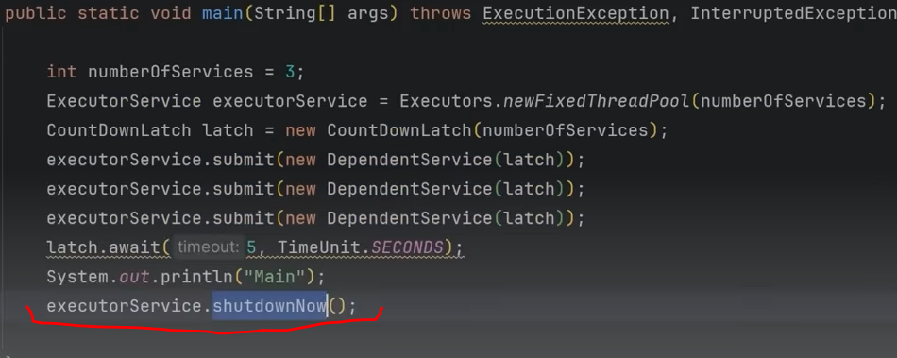

.shutdownNow() will terminate the worker threads immediately.

**CyclicBarrier** – It is reusable

CountDownLatch is not reusable, once the count reaches 0 it cannot be reset.

In cyclic barrier, multiple threads wait at a point until all threads reached at that point. When the last thread reaches the barrier then all threads are released. It does not block main thread. It is used to make sure that certain no of threads reach at a particular point before any of them proceed.

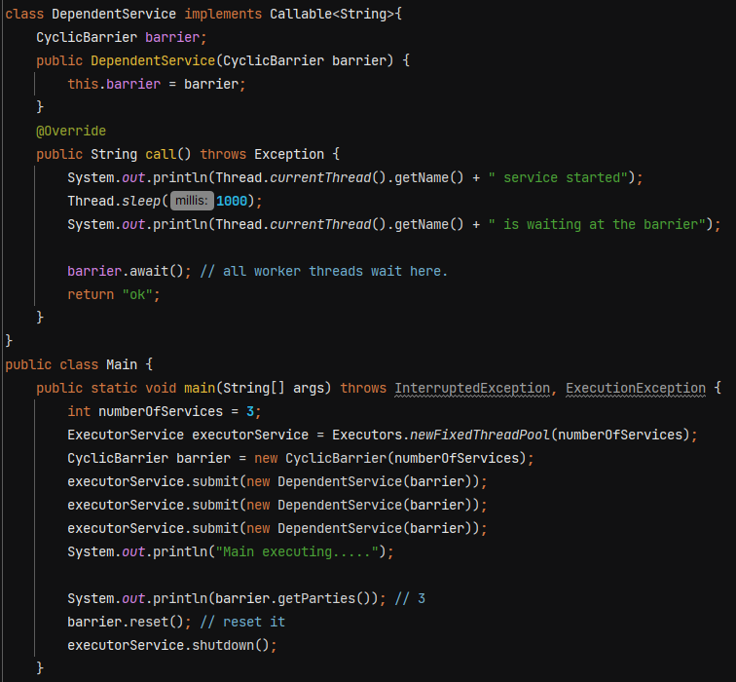

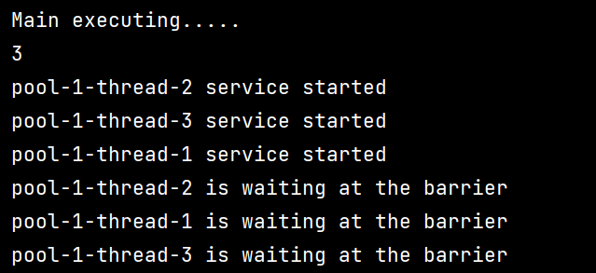

**await()** 🡺 Waits until all parties have invoked await on this barrier.

**getParties()** 🡺 Returns the number of parties required to trip this barrier.

**reset()** 🡺Resets the barrier to its initial state. If any parties are currently waiting at the barrier, they will return with a BrokenBarrierException.

Ex- image a big application having multiple subsystem

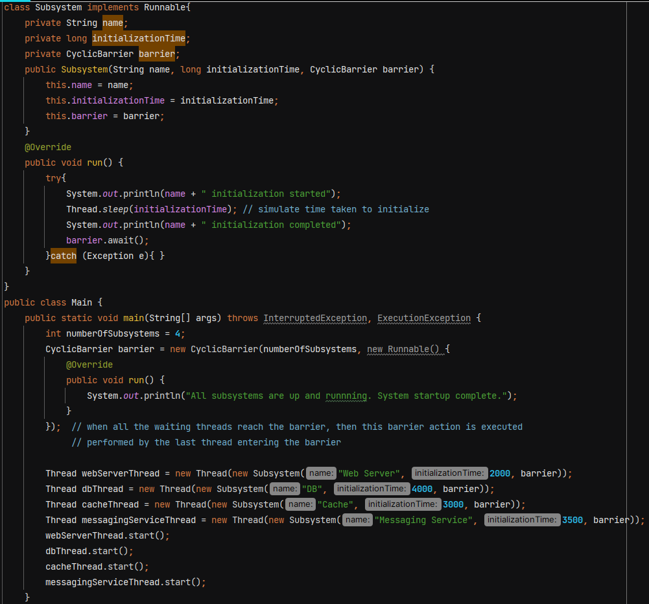

O/P 🡪 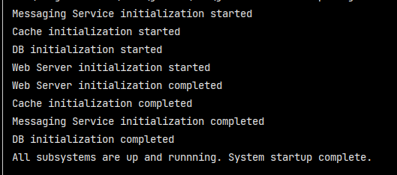

**CompletableFuture**

Introduced in JAVA 8 to handle asynchronous programming

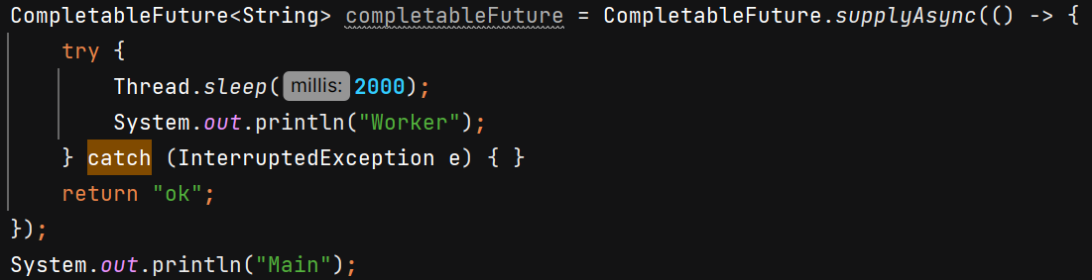

O/P 🡪 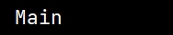

we don’t see sout of “Worker” because by default, CompletableFuture.supplyAsync() uses the **ForkJoinPool.commonPool()**, and the threads in this pool are **daemon threads**.

If we want to run the task –

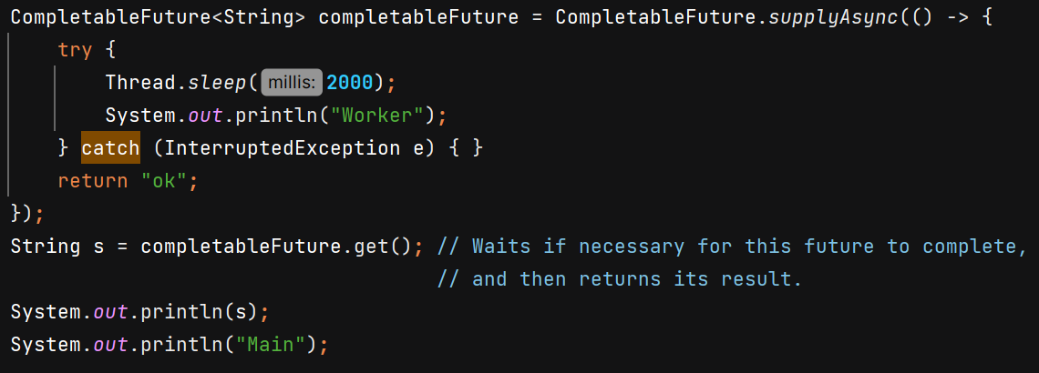

O/P 🡪 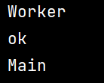

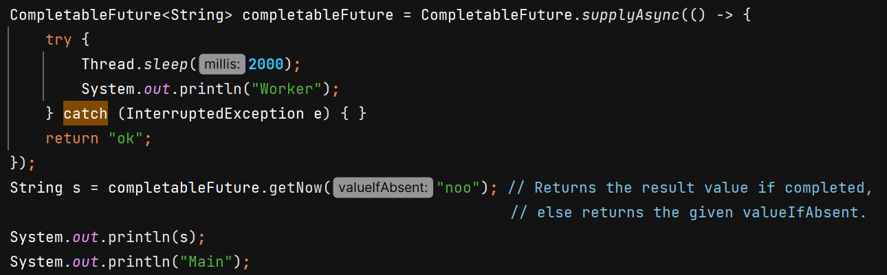

O/P 🡪 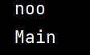

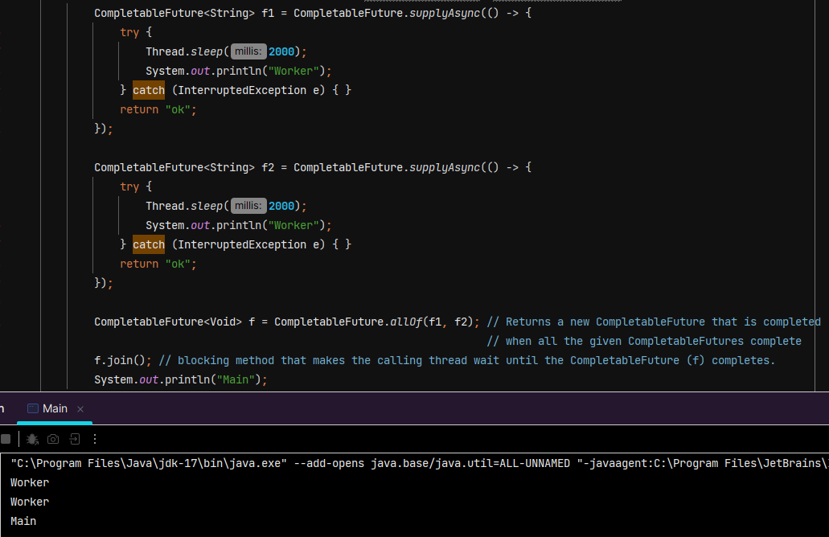

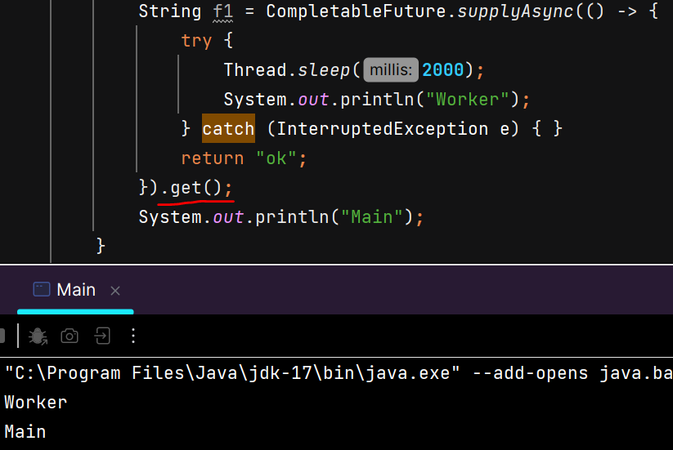

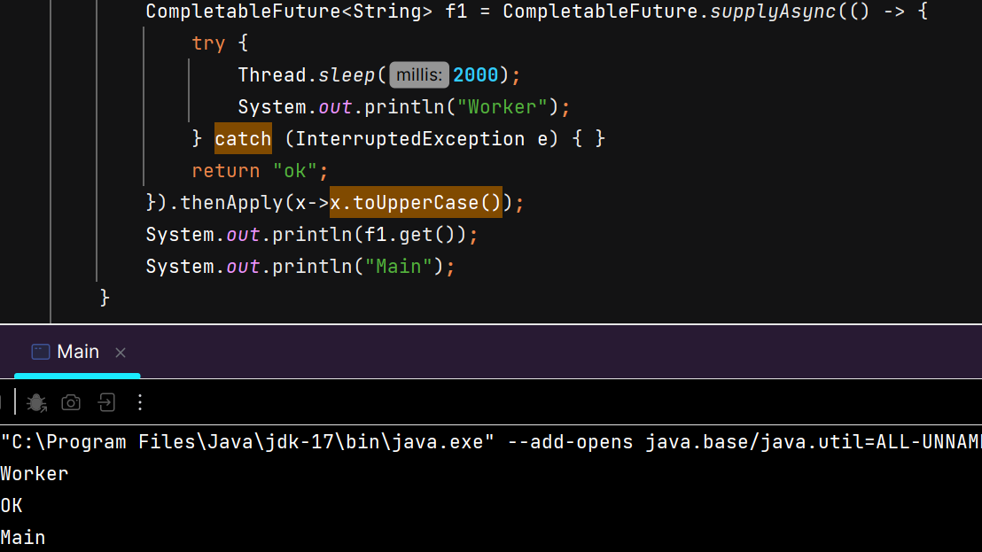

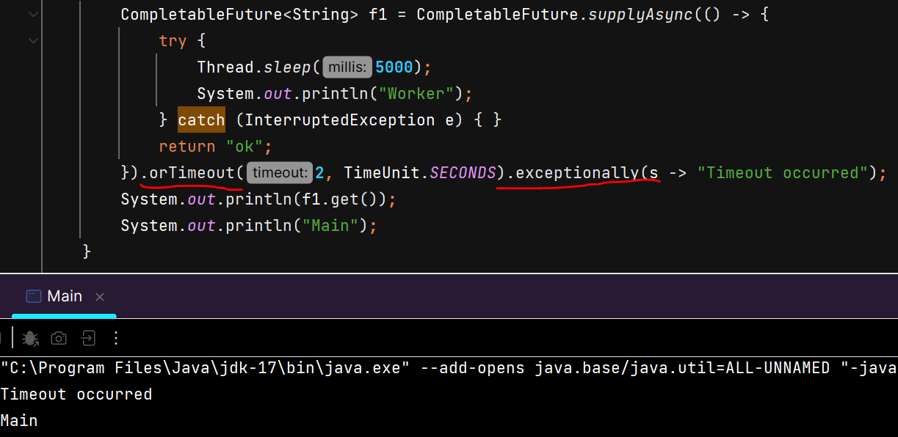

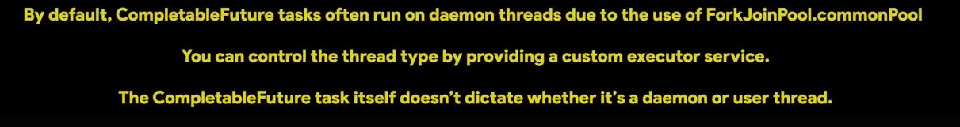

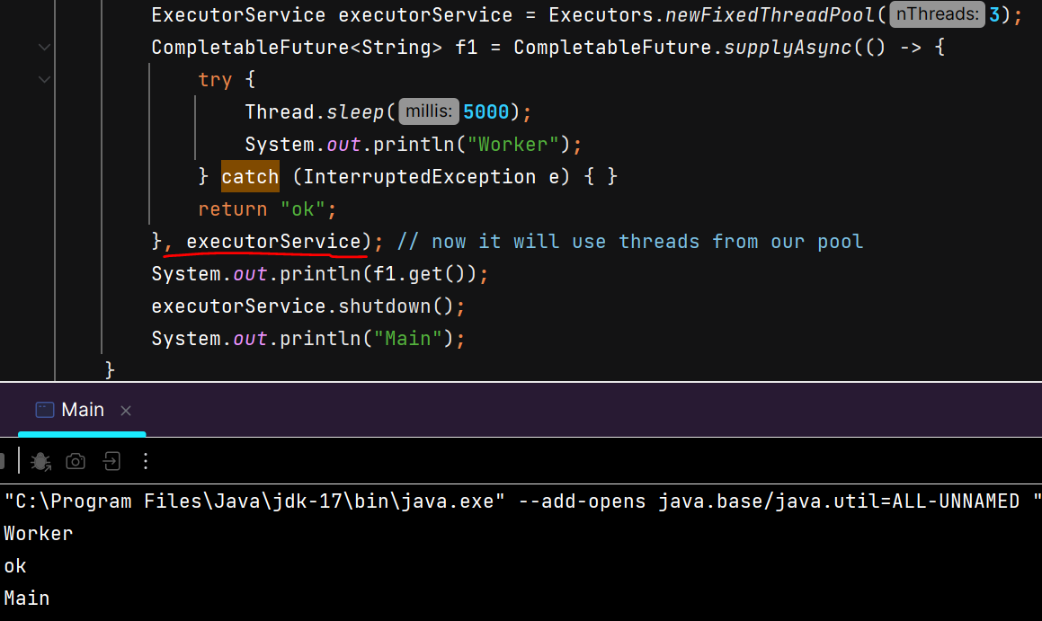

**Volatile vs Atomic**

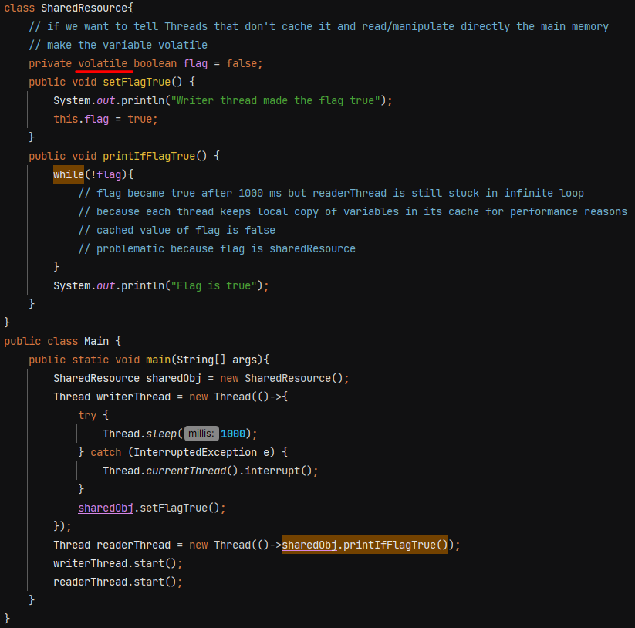

If we don’t make variable volatile then readerThread is stuck in infinite loop. But in complex scenarios it also has disadvantages as there is no thread safety.

AtomicInteger, AtomicLong, AtomicBoolean - does not use locks. It achieves thread safety using **non-blocking, lock-free algorithms** that rely on **low-level hardware support** for atomic operations.

